SECTION 5.120: MIDDLE HOUSING STANDARDS

1. PURPOSE. The purpose of the middle housing standards is to ensure that new middle housing can be integrated into the unincorporated communities where it is permitted, and reviewed according to clear and objective standards. Middle housing includes triplexes, quadplexes, townhouses and cottage clusters, intended to provide an alternative to single-family dwellings for greater flexibility that can include dwellings of different sizes and configurations.
2. SUFFICIENT INFRASTRUCTURE. Applicants must demonstrate that sufficient infrastructure is provided, or will be provided, upon submittal of an application for a triplex, quadplex, townhouse project or cottage cluster, including:
   1. Connection to a public sewer system capable of meeting established service levels;
   2. Connection to a public water system capable of meeting established service levels;
   3. Access via public or private streets meeting adopted emergency vehicle access standards to a public street system; and
   4. Storm drainage facilities capable of meeting established service levels for storm drainage.
3. TRIPLEX AND QUADPLEX DESIGN STANDARDS.
   1. Entry Orientation. At least one main entrance for each triplex or quadplex structure must meet the standards below. Any detached structure for which more than 50 percent of its street-facing facade is separated from the street property line by a dwelling is exempt from meeting these standards.
      1. The entrance must be within 8 feet of the longest street-facing wall of the dwelling unit; and
      2. The entrance must either:
         1. Face the street (see Figure 5.120(3)-1);
         2. Be at an angle of up to 45 degrees from the street (see Figure 5.120(3)-2);
         3. Face a common open space that is adjacent to the street and is abutted by dwellings on at least two sides (see Figure 5.120(3)-3); or
         4. Open onto a porch that is at least 25 square feet in area, and that must have at least one entrance facing the street or have a roof (see Figure 5.120(3)-4).

Figure 5.120(3)-1

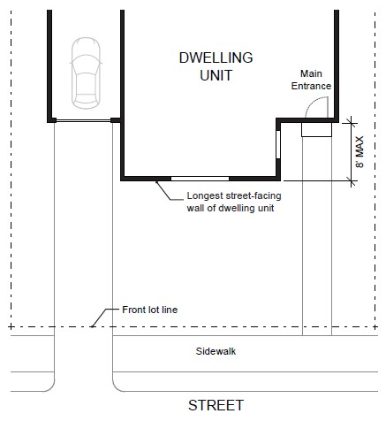

Figure 5.120(3)-2

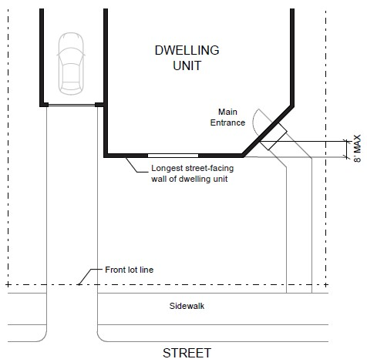

Figure 5.120(3)-3

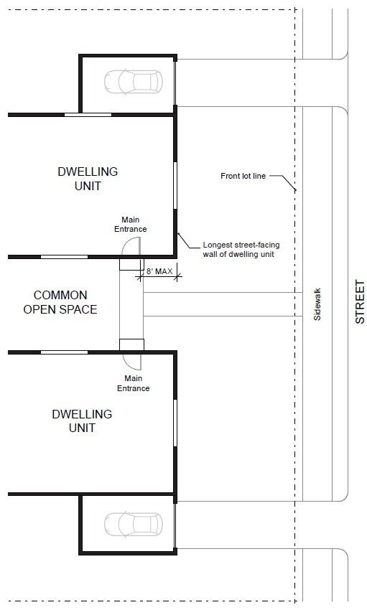

Figure 5.120(3)-4

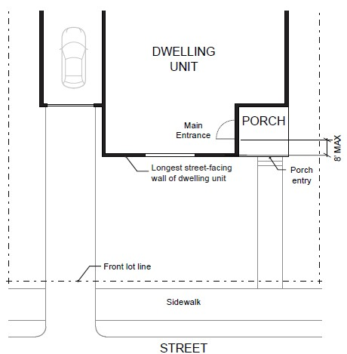

* 1. Windows. A minimum of 15 percent of the area of all street-facing facades must include windows or entrance doors. Facades separated from the street property line by a dwelling are exempt from meeting this standard. See Figure 5.120(3)-5.

Figure 5.120(3)-5

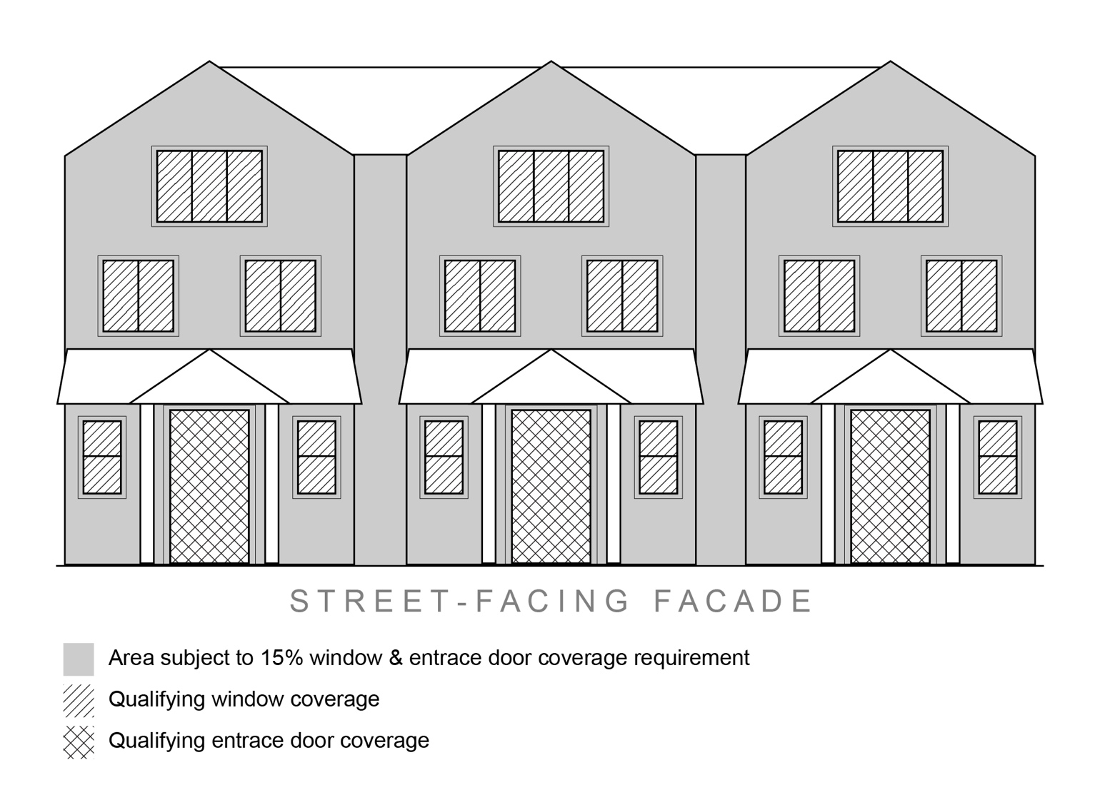

* 1. Garages and Off-Street Parking Areas. Garages and off-street parking areas shall not be located between a building and a public street (other than an alley), except where they comply with the following standards:
     1. The garage or off-street parking area is separated from the street property line by a dwelling; or
     2. The combined width of all garages and outdoor on-site parking and maneuvering areas does not exceed a total of 50 percent of the street frontage (see Figure 5.120(3)-6), and driveways must meet the access spacing standards in (section).

Figure 5.120(3)-6

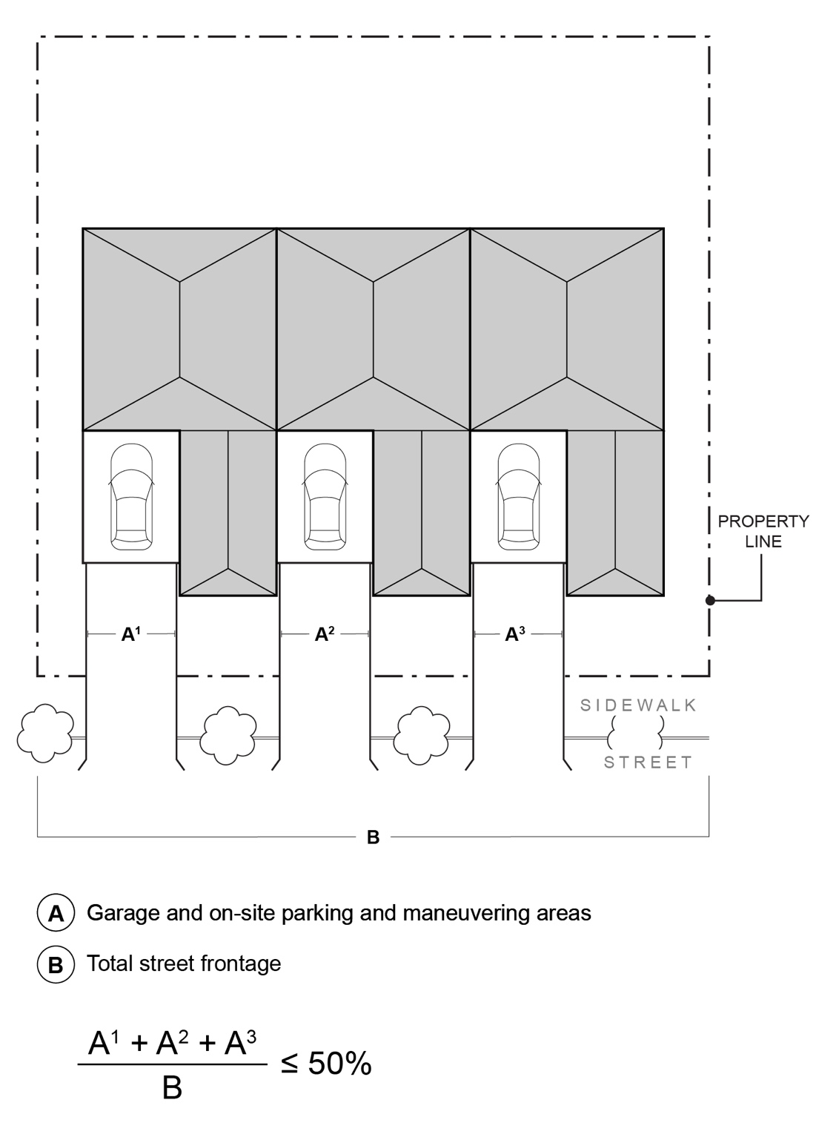

* 1. Conversions. Internal conversion of an existing detached single-family dwelling or duplex to a triplex or quadplex is subject to the following standards:
     1. Conversions are exempt from the design standards of subsections (a) through (c), and
     2. Conversions are exempt from the minimum parking requirements in Section 4.030.
     3. Notwithstanding Article VII, a nonconforming structure that is an existing single-family dwelling or duplex may be converted to a triplex or quadplex without review provided that the conversion does not increase nonconformance with applicable clear and objective standards.

1. TOWNHOUSE DESIGN STANDARDS.
   1. Development Standards. The development standards of the applicable base zone apply, with the following exceptions and additions:
      1. The side setback where townhouse units are attached shall be zero feet.
   2. Entry Orientation. The main entrance of each townhouse must:
      1. The entrance must be within 8 feet of the longest street-facing wall of the dwelling unit; and
      2. The entrance must either:
         1. Face the street (see Figure 5.120(3)-1);
         2. Be at an angle of up to 45 degrees from the street (see Figure 5.120(3)-2);
         3. Face a common open space that is adjacent to the street and is abutted by dwellings on at least two sides (see Figure 5.120(3)-3); or
         4. Open onto a porch that is at least 25 square feet in area, and that must have at least one entrance facing the street or have a roof (see Figure 5.120(3)-4).
   3. Unit Definition. Each townhouse must include at least one of the following on at least one street-facing façade (see Figure 5.120(4)-1):
      1. A roof dormer a minimum of four feet in width, or
      2. A balcony a minimum of two feet in depth and four feet in width and accessible from an interior room, or
      3. A bay window that extends from the façade a minimum of two feet, or
      4. An offset of the façade of a minimum of two feet in depth, either from the neighboring townhouse or within the façade of a single townhouse, or
      5. An entryway that is recessed a minimum of three feet, or
      6. A covered entryway with a minimum depth of four feet, or
      7. A porch with at least 25 square feet in area, and at least one entrance facing the street or have a roof.

Balconies and bay windows may encroach into a required setback area.

Figure 5.120(4)-1

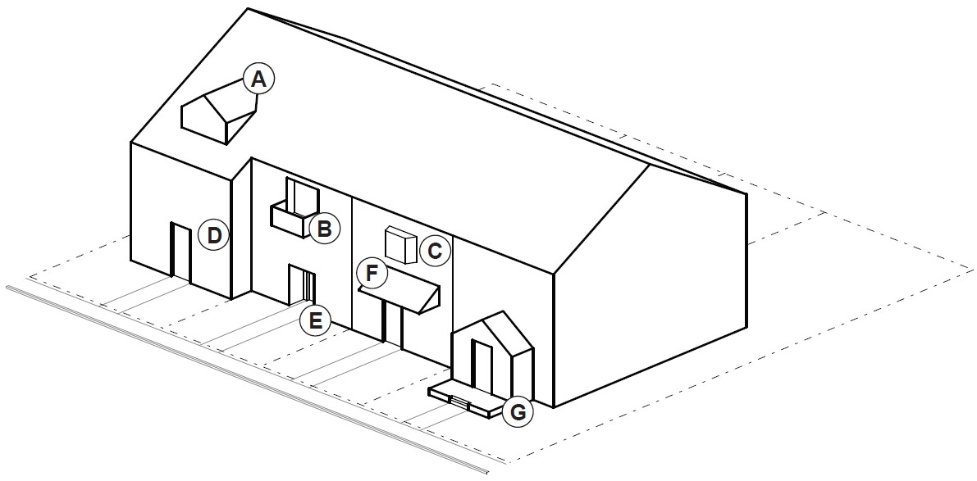

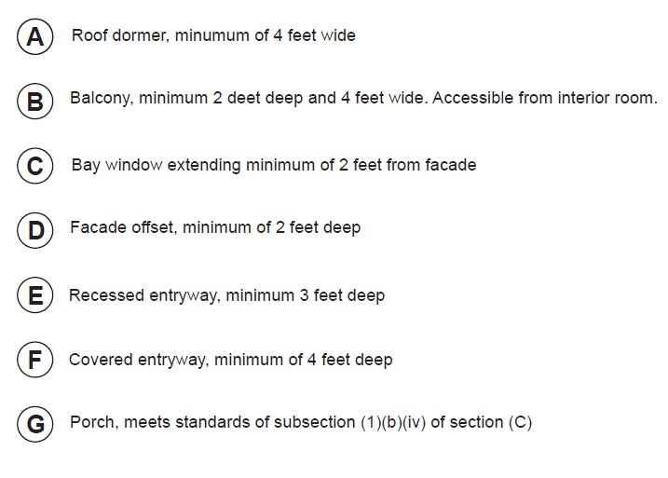

* 1. Windows. A minimum of 15 percent of the area of all street-facing facades on each individual unit must include windows or entrance doors. Half of the window area in the door of an attached garage may count toward meeting this standard. See Figure 5.120(3)-5.
  2. Driveway Access and Parking. Townhouses with frontage on a public street shall meet the following standards:
     1. Garages on the front façade of a townhouse, off-street parking areas in the front yard, and driveways in front of a townhouse are allowed if they meet the following standards (see Figure 5.120(4)-2):
        1. Each townhouse lot has a street frontage of at least 20 feet on a local street.
        2. A maximum of one driveway per lot is allowed that does not exceed 12 feet wide. For two abutting lots in the same townhouse project, driveways are encouraged to be paired and abut along the lot line to create one shared driveway approach.
        3. The garage width does not exceed 12 feet wide, as measured from the inside of the garage door frame.

Figure 5.120(4)-2

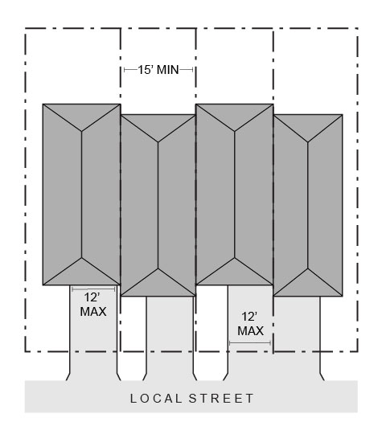

* + 1. The follow standards apply to driveways and parking areas for townhouse projects that do not meet all of the standards in subsection (i).
       1. Off-street parking areas shall be accessed on the back façade or located in the rear yard. No off-street parking shall be allowed in the front yard or side yard of a townhouse.
       2. A townhouse project that includes a corner lot shall take access from a single driveway approach on the side of the corner lot. See Figure 5.120(4)-3.

Figure 5.120(4)-3

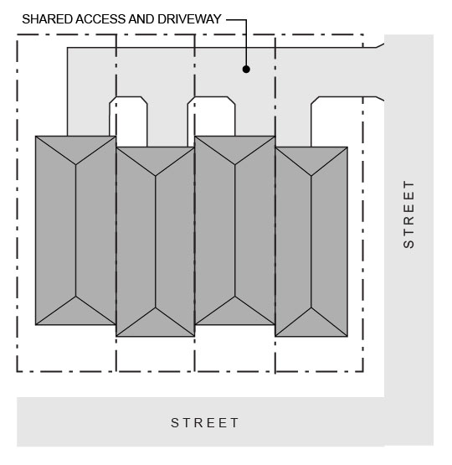

* + - 1. Townhouse projects that do not include a corner lot shall consolidate access for all lots into a single driveway. The driveway and approach are not allowed in the areas directly between the front façade and the front lot line of any of the townhouses. See Figure 5.120(4)-4.

Figure 5.120(4)-4

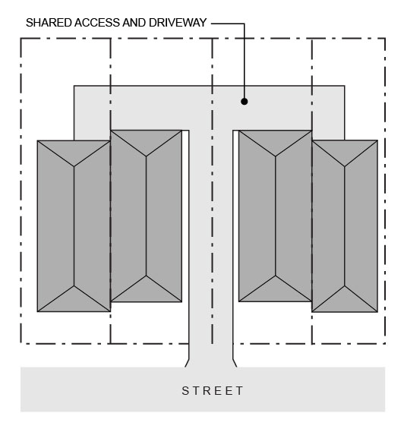

* + - 1. A townhouse project that includes consolidated access or shared driveways shall grant access easements to allow normal vehicular access and emergency access.
    1. Townhouse projects in which all units take exclusive access from a rear alley are exempt from compliance with subsection (ii).

1. COTTAGE CLUSTER DESIGN STANDARDS.
   1. Development Standards. The development standards of the applicable base zone apply, with the following exceptions and additions:
      1. The maximum building footprint for a cottage in a cottage cluster shall be 900 square feet.
      2. The maximum floor area for a cottage in a cottage cluster shall be:
         1. 900 square feet in the Residential Oceanside (ROS), (list others…) zone.
         2. 1,200, 1,400, 1,800 square feet?? In other zones.
      3. The maximum height for cottage clusters shall be:
         1. 17 feet in the Residential Oceanside (ROS), (list others…) zone.
         2. 25 feet in all other zones.
      4. A minimum density of four units per net acre shall apply to cottage clusters in all zones.
      5. No minimum setback shall exceed 10 feet in all zones.
      6. Cottages shall be separated by a minimum distance of 10 feet. The minimum distance between all other structures, including accessory structures, shall be in accordance with building code requirements.
      7. A minimum of three cottages and a maximum of eight cottages shall be permitted per common courtyard.
   2. Cottage Orientation. Cottages must be clustered around a common courtyard, meaning they abut the associated common courtyard or are directly connected to it by a pedestrian path, and must meet the following standards (see Figure 5.120(5)-1):
      1. Each cottage within a cluster must either abut the common courtyard or must be directly connected to it by a pedestrian path.
      2. A minimum of 50 percent of cottages within a cluster must be oriented to the common courtyard and must:
         1. Have a main entrance facing the common courtyard;
         2. Be within 10 feet from the common courtyard, measured from the façade of the cottage to the nearest edge of the common courtyard; and
         3. Be connected to the common courtyard by a pedestrian path.
      3. Cottages within 20 feet of a street property line may have their entrances facing the street.
      4. Cottages not facing the common courtyard or the street must have their main entrances facing a pedestrian path that is directly connected to the common courtyard.
   3. Common Courtyard Design Standards. Each cottage cluster must share a common courtyard in order to provide a sense of openness and community of residents. Common courtyards must meet the following standards (see Figure 5.120(5)-1):
      1. The common courtyard must be a single, contiguous piece.
      2. Cottages must abut the common courtyard on at least two sides of the courtyard.
      3. The common courtyard must contain a minimum of 150 square feet per cottage within the associated cluster.
      4. The common courtyard must be a minimum of 15 feet wide at its narrowest dimension.
      5. The common courtyard shall be developed with a mix of landscaping, lawn area, pedestrian paths, and/or paved courtyard area, and may also include recreational amenities. Impervious elements of the common courtyard shall not exceed 75 percent of the total common courtyard area.
      6. Pedestrian paths must be included in a common courtyard. Paths that are contiguous to a courtyard shall count toward the courtyard’s minimum dimension and area. Parking areas, required setbacks, and driveways do not qualify as part of a common courtyard.

Figure 5.120(5)-1

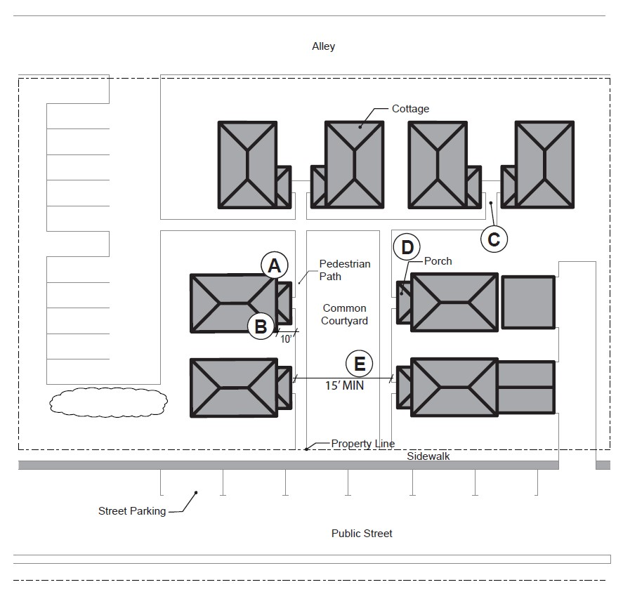

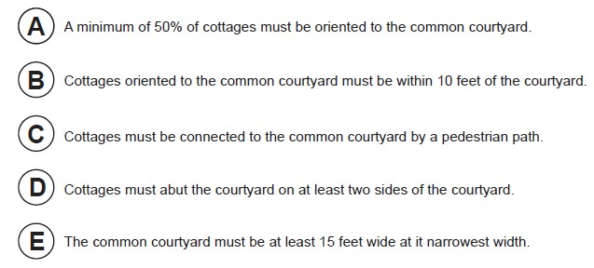

* 1. Community Buildings. Cottage cluster projects may include community buildings for the shared use of residents that provide space for accessory uses such as community meeting rooms, guest housing, exercise rooms, day care, or community eating areas. Community buildings may be no larger than 900 square feet.
  2. Pedestrian Access.
     1. An accessible pedestrian path must be provided that connects the main entrance of each cottage to the following:
        1. The common courtyard;
        2. Shared parking areas;
        3. Community buildings; and
        4. Sidewalks in public rights-of-way abutting the site or rights-of-way if there are no sidewalks.
     2. The pedestrian path must be hard-surfaced and a minimum of four feet wide.
  3. Parking Design
     1. Clustered parking. Off-street parking may be arranged in clusters, subject to the following standards:
        1. Cottage cluster projects with fewer than 16 cottages are permitted parking clusters of not more than five contiguous spaces.
        2. Cottage cluster projects with 16 cottages or more are permitted parking clusters of not more than eight contiguous spaces.
        3. Parking clusters must be separated from other spaces by at least four feet of landscaping.
        4. Clustered parking areas may be covered.
     2. Parking location and access.
        1. Off-street parking spaces and vehicle maneuvering areas shall not be located:
           + Within of 10 feet from any street property line, except alley property lines;
           + Between a street property line and the front façade of cottages located closest to the street property line. This standard does not apply to alleys.
        2. Off-street parking spaces shall not be located within 10 feet of any other property line, except alley property lines. Driveways and drive aisles are permitted within 10 feet of other property lines.
     3. Screening. Landscaping, fencing, or walls at least three feet tall shall separate clustered parking areas and parking structures from common courtyards and public streets.
     4. Garages and carports.
        1. Garages and carports (whether shared or individual) must not abut common courtyards.
        2. Individual attached garages up to 200 square feet shall be exempted from the calculation of maximum building footprint for cottages.
        3. Individual detached garages must not exceed 400 square feet in floor area.
        4. Garage doors for attached and detached individual garages must not exceed 20 feet in width.

Figure 5.120(5)-2

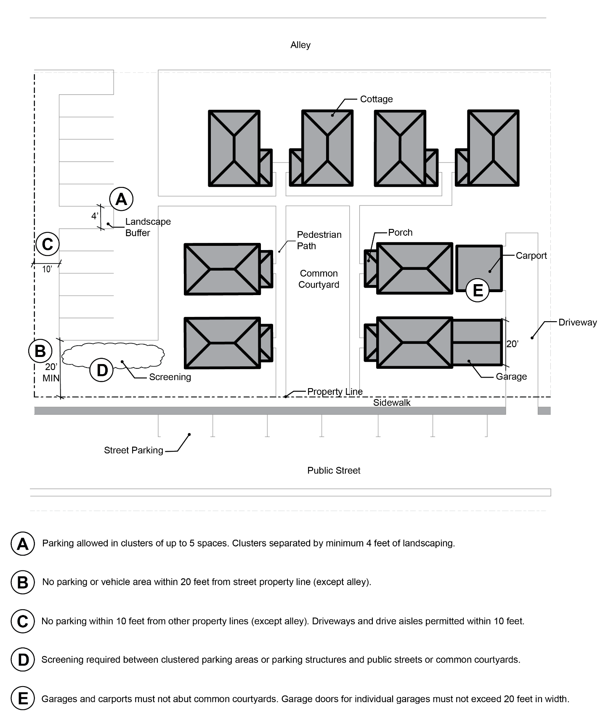

* 1. Existing Dwellings. On a lot or parcel to be used for a cottage cluster project, an existing single-family dwelling on the same lot at the time of proposed development of the cottage cluster may be incorporated into the cottage cluster under the following conditions:
     1. The existing dwelling may be nonconforming with respect to the requirements of this code.
     2. The existing dwelling may be expanded up to the maximum height, building footprint and floor area allowed in subsection (a). Existing dwellings that exceed the maximum height, footprint and/or floor area of this code may not be expanded.
     3. The existing dwelling shall be excluded from the calculation of orientation toward the common courtyard required in subsection (b).