Community Annex C Cape Lookout State Park
1 Community Overview 2
2 Existing Evacuation Facilities Analysis 2
3 Evacuation Improvements Project Identification 6
3.1 Wayfinding 6
3.2 Planning 7
3.3 Construction 7

1 Community Overview
Cape Lookout State Park is a popular campground and day-use area within the Oregon State Parks system. With capacity of over 170 tent sites, 38 full-hookup sites, and 13 yurts, the park is often at full capacity during the summer months. Cape Lookout is situated to the south end of Netarts and is surrounded by the Pacific Ocean directly to the west and Netarts Bay and Whiskey Creek Rd to the east.

2 Existing Evacuation Facilities Analysis

Tsunami Wave Arrival Time
In the XXL scenario, waves will begin to arrive at the beach and western extents of the spit in approximately 20 minutes after the earthquake begins. The wave crosses the area fairly uniformly from west to east, entirely inundating Netarts Spit. The wave will continue across Netarts Bay and arrive at the eastern most area of the inundation zone 25-26 minutes after the earthquake begins. It should be noted that Cape Lookout State Park south of Cape Lookout Viewpoint is entirely outside of the inundation zones due to the presence of high cliffs.
See Appendix B for maps.

Existing Evacuations Routes and Signage
The TEFIP relies on the presence of existing infrastructure and signage to inform improvement planning. While most of the existing signage is accurate, several communities have infrastructure and signage that is either inaccurate or requiring enhancement. It is recommended that all existing signage at Cape Lookout State Park be revisited, as it is designed for vehicle traffic, and should be aligned with the working assumption that evacuees should expect to evacuate on foot. The area has existing signage at the following locations (see Figure 1 for location of signs plotted on map):
Type | Description | Location
Route Sign | Existing route sign at southern extent of day-use parking lot pointing north toward Whiskey Creek Rd. | 45.36055, -123.97
 | Existing route sign in day-use parking lot pointing north toward Whiskey Creek Rd. | 45.36151, -123.969
 | The campground site contains numerous signs directing evacuees in a circular motion around the parking lot’s one-way traffic. | 45.36363, -123.968
 | Existing route sign at camp entrance pointing south on Whiskey Creek Rd. | 45.3666, -123.962

Figure 1 Existing Evacuation Signage
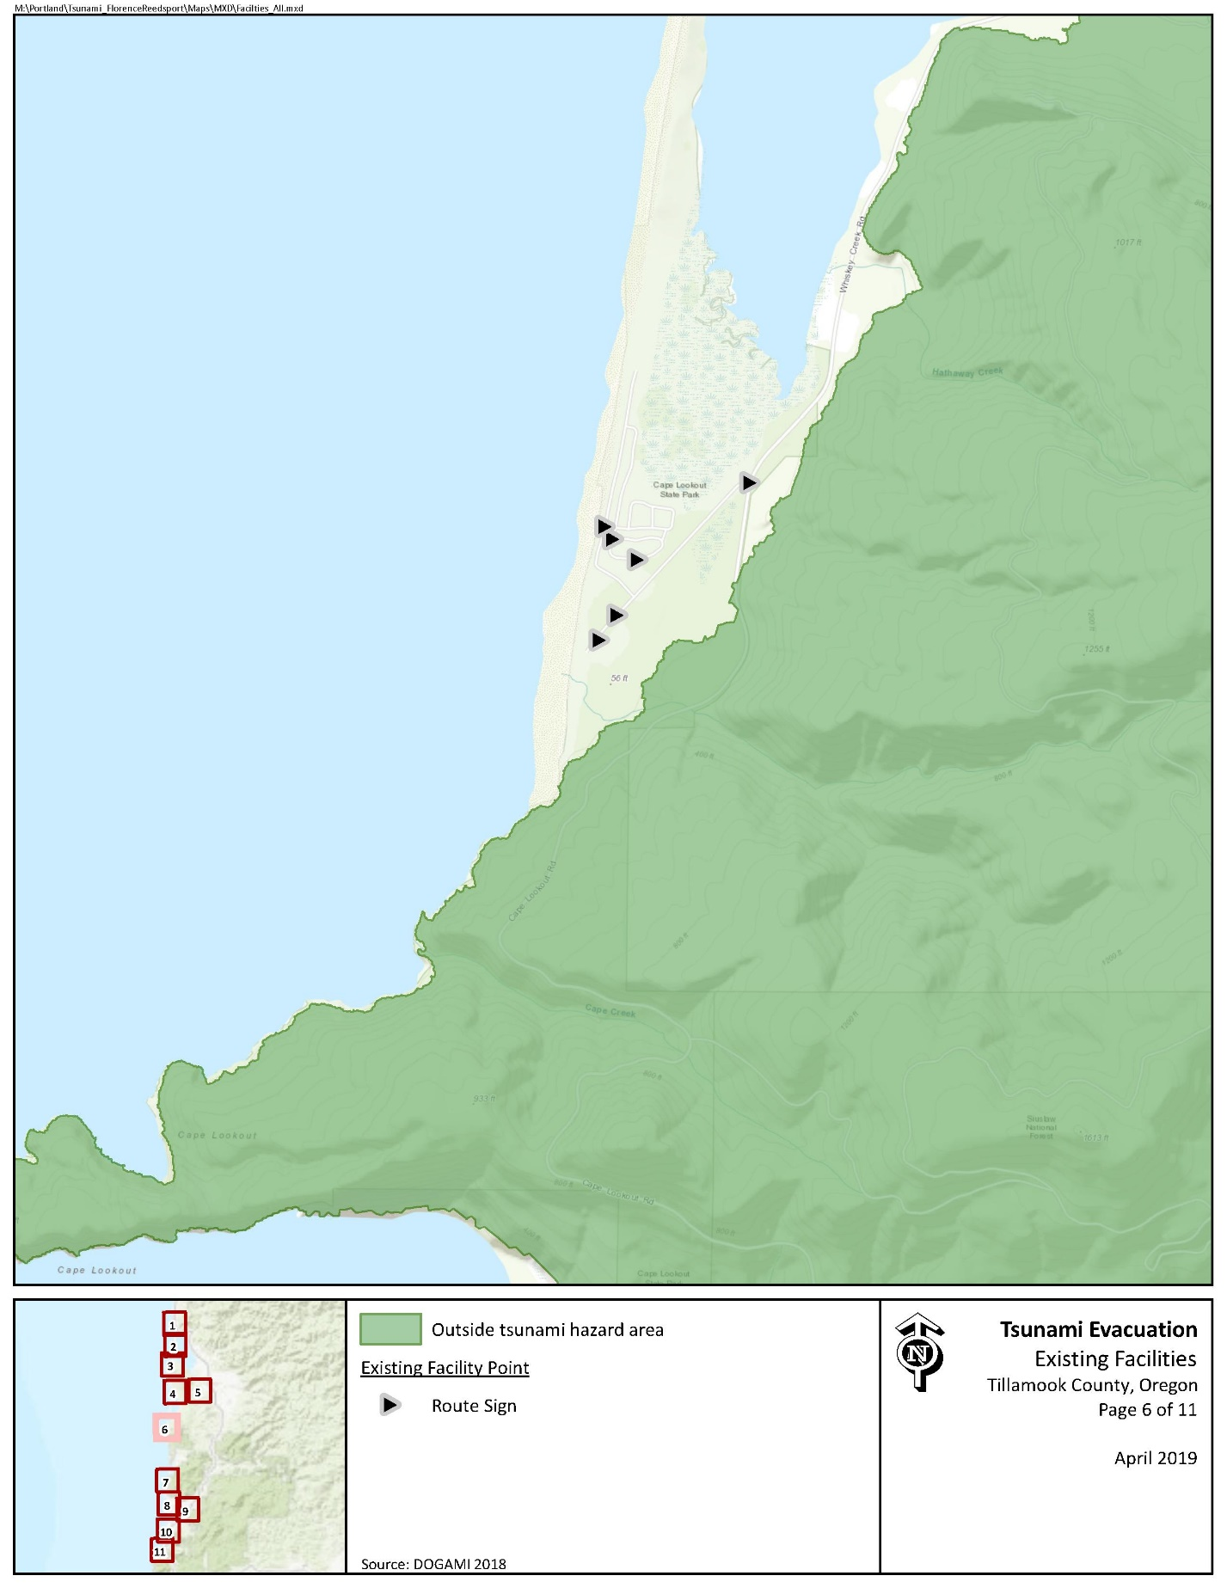

Evacuation Speeds
Evacuation speeds required to reach safety range a walk to fast walk in much of the day-use and campground facilities. In addition, run, sprint, and even unlikely to survive areas exist along Netarts Spit and along the coastline.

Figure 2 Minimum Walking Speeds
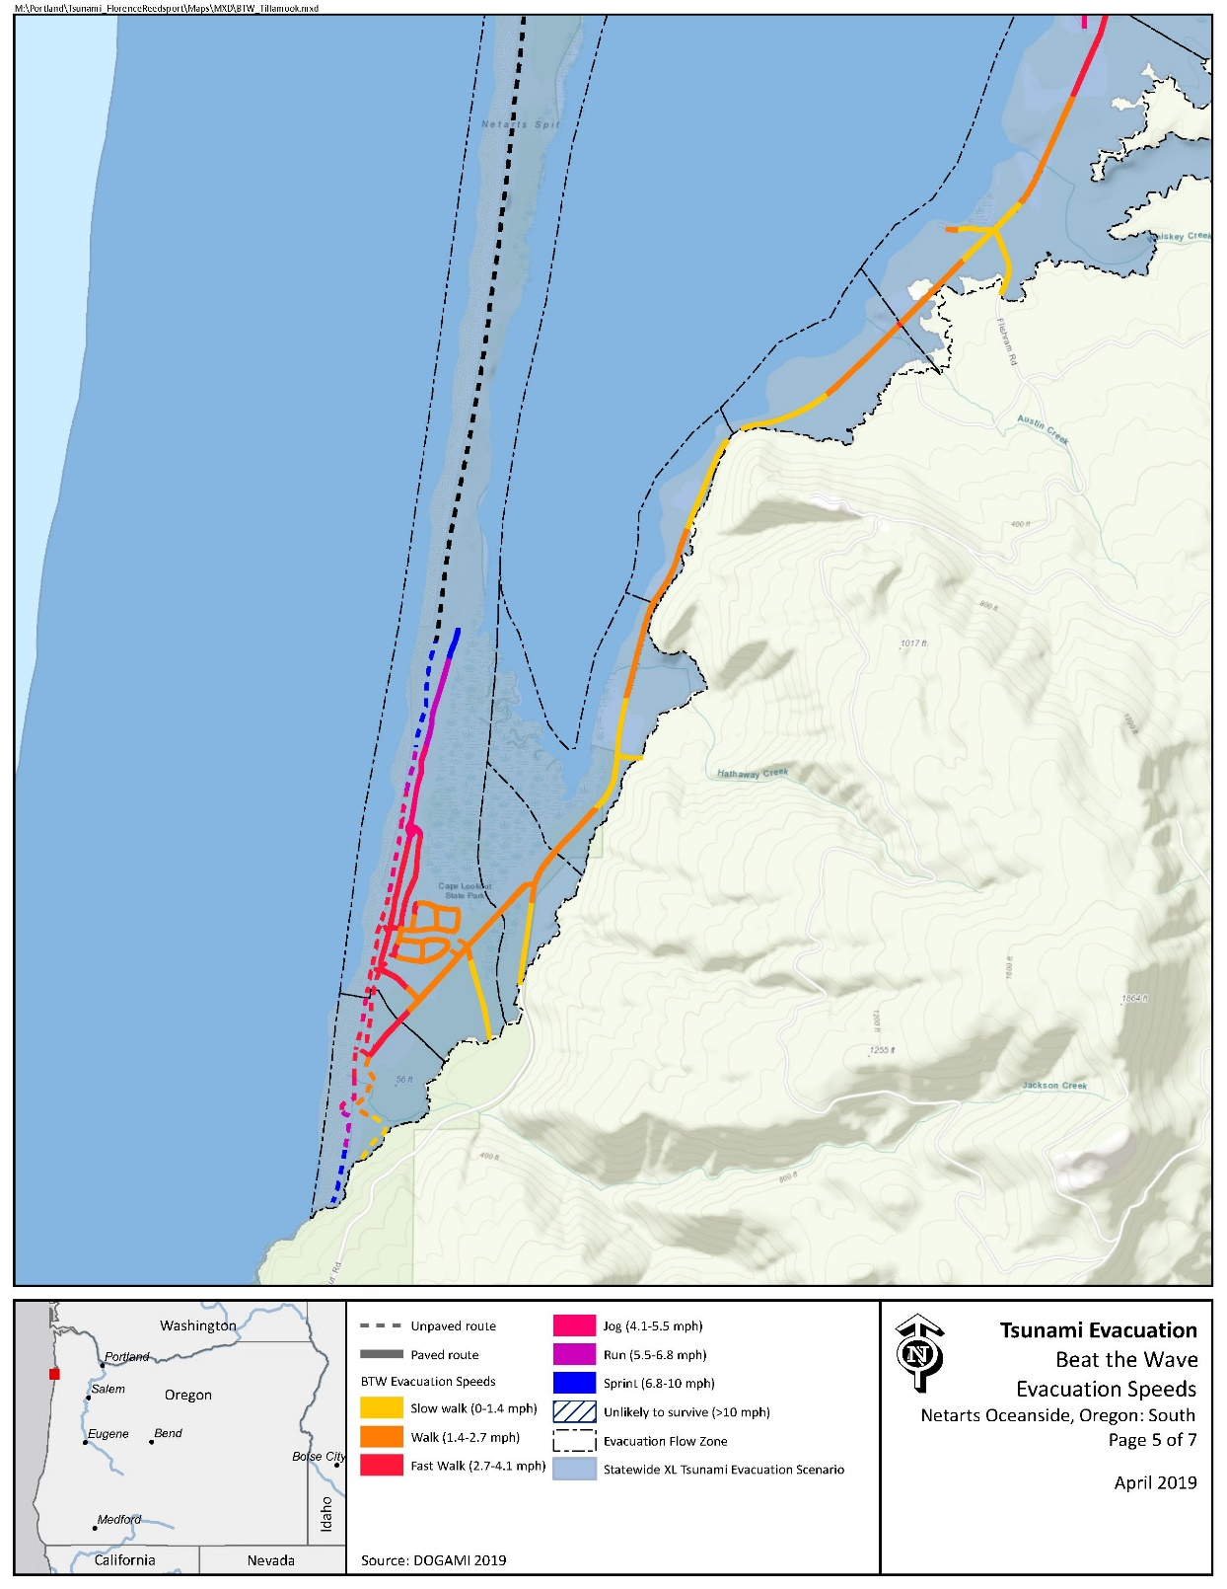

Critical Facilities
There are no critical facilities located within this area.

Conclusions
Existing evacuation signage is largely devoted to route signage along the campground vicinity. No maps or other supporting infrastructure were identified. In addition, existing signage has been oriented around vehicular-based evacuations and should be replaced with updated signage to support foot-based evacuation along the shortest travelable routes.

3 Evacuation Improvements Project Identification

3.1 Wayfinding

The following wayfinding projects have been grouped together under a singular problem statement, as they all attempt to solve a similar issue.
Problem Statement: Limited existing signage and knowledge of priority evacuation routes may present difficulty to residents and visitors in evacuating from the inundation zone.
Prioritized Project Alternatives:
Project ID | Type | Description | Location | Priority | Potential Project Partners | Estimated Cost
1221 | Blue Line | Existing route signage directs evacuees south on Whiskey Creek Rd but does not indicate the location of high ground. It is recommended that a Blue Line or “Leaving Zone” sign be placed on Whiskey Creek Rd outside of the inundation zone. | 45.362838, -123.962904 | High | Oregon State Parks, County Community Development, DLCD | $138.80 per sign plus labor and installation costs
1621 | Route Sign | An existing trail exists on the campground access road approximately 0.2 miles from Whiskey Creek Rd. It is recommended that route signage be placed directing evacuees along the trail to high ground at the Blue Line identified in Project 1221. | 45.363991, -123.965876 | High | Oregon State Parks, County Community Development, DLCD | $61 per sign and arrow plus labor and installation costs
4816 | Map | An existing “Tsunami Hazard Area” sign exists at beach access within the campground. It is recommended that a tsunami inundation zone map be placed at the beach access to improve local awareness. | 45.363418, -123.970318 | High | Oregon State Parks, County Community Development, DLCD | $5,000 per sign
1 | Route Sign | An existing trail exists at the eastern edge of the campground that would allow for enhanced evacuation effectiveness. It is recommended that route signage be re-oriented around this location. | 45.365137, -123.966241 | High | Oregon State Parks, County Community Development, DLCD | $61 per sign and arrow plus labor and installation costs
560 | Map | It is recommended that a tsunami inundation zone map be placed at the Cape Lookout Picnic Shelter to improve local awareness. | 45.360244, -123.970755 | High | Oregon State Parks, County Community Development, DLCD | $5,000 per sign
Potential Funding Sources: Wayfinding projects can often be implemented at minimal cost by utilizing existing, ineffectively-placed signage. However, the NOAA/NWS National Tsunami Hazard Mitigation Program (NTHMP) also provides grants to fund projects throughout coastal communities. In addition, as the area is owned by the State, Oregon State Parks may be able to provide project funding.
Project Beneficiaries: Wayfinding projects generally support all stakeholders in helping to promote an efficient evacuation process. In particular, campers and day-use visitors benefit from the presence of maps and route signs to institutionalize knowledge among groups that may not be as familiar with tsunami risks.

3.2 Planning
Problem Statement: Existing signage throughout Cape Lookout State Park is inadequate and oriented around vehicular evacuations.
Prioritized Project Alternatives:
- As this location is State land, coordination is required between Tillamook County and Oregon State Parks to update signage and enhance public awareness and education. It is recommended that Tillamook County establish a working group with Oregon State Parks to determine opportunities to enhance evacuation infrastructure throughout the area.

3.3 Construction
Project ID | Type | Description | Location | Priority | Potential Project Partners | Potential Funding Sources | Estimated Cost
401 | Trail Enhancement | High ground is relatively near to the day-use parking lot but is currently inaccessible due to heavy vegetation. It is recommended that a trail be established to cut through the vegetation toward Whiskey Creek Rd. | 45.360000, -123.968909 | Medium | Oregon State Parks | Oregon State Parks, FEMA HMA | Potentially minimal with in-kind labor and materials.

