Community Annex D Neskowin
1 Community Overview 2
2 Existing Evacuation Facilities Analysis 2
3 Evacuation Improvements Project Identification 8
3.1 Wayfinding 8
3.2 Planning 9
3.3 Construction 9

1 Community Overview
Neskowin is a popular vacation destination, with many residential structures serving as secondary homes and rental properties. The community is bisected by Neskowin Creek, which creates two informal communities.

2 Existing Evacuation Facilities Analysis

Tsunami Wave Arrival Time
In the XXL scenario, waves will begin to arrive at the beach in approximately 20 minutes after the earthquake begins. The wave crosses the area fairly uniformly from west to east with very few abnormalities. Within the South Beach and Neskowin Proper vicinities, nearly all residential properties reside within the inundation zone.
See Appendix B for maps.

Existing Evacuations Routes and Signage
The TEFIP relies on the presence of existing infrastructure and signage to inform improvement planning. While most of the existing signage is accurate, several communities have infrastructure and signage that is either inaccurate or requiring enhancement. The area has existing signage at the following locations (see Figure 1 for location of signs plotted on map):
Type | Description | Recommended Improvement? (x) | Location
Blue Line | Existing “Leaving Zone” sign at an elevation that is still within the XXL scenario. | X – See Project 4001 | 45.11116, -123.973
Blue Line | Existing “Entering Zone” sign pointing north on Highway 101 south of Oretown Rd. |  | 45.15443, -123.955
Route Sign | Existing route sign pointing east onto Summit Rd. |  | 45.10324, -123.981
Route Sign | Existing route signage pointing toward Tsunami Trail, which are accompanied by trail markers. |  | 45.11253, -123.979
Route Sign | Existing route sign pointing north on Hawk St just north of locked electric gate. |  | 45.12316, -123.977
Route Sign | Existing route sign at northern extent of Hawk St with arrow pointing north into vegetated area. | X – See Project 3213 | 45.12417, -123.977
Route Sign | Existing route sign pointing north on Winema Rd south of Wi-Ne-Ma Christian Camp. |  | 45.14516, -123.973
Route Sign | Existing route sign pointing east toward Highway 101 on Wi Ne Ma Rd at Wi-Ne-Ma Christian Camp. |  | 45.14658, -123.973
Trail and Bridge | Pedestrian bridge existing. May requiring fording the river if out. Currently 3.8 ft depth with beaver dams around. | X – See Project 2815 | 45.11246, -123.978

Figure 1 Existing Evacuation Signage – North Neskowin and Winema
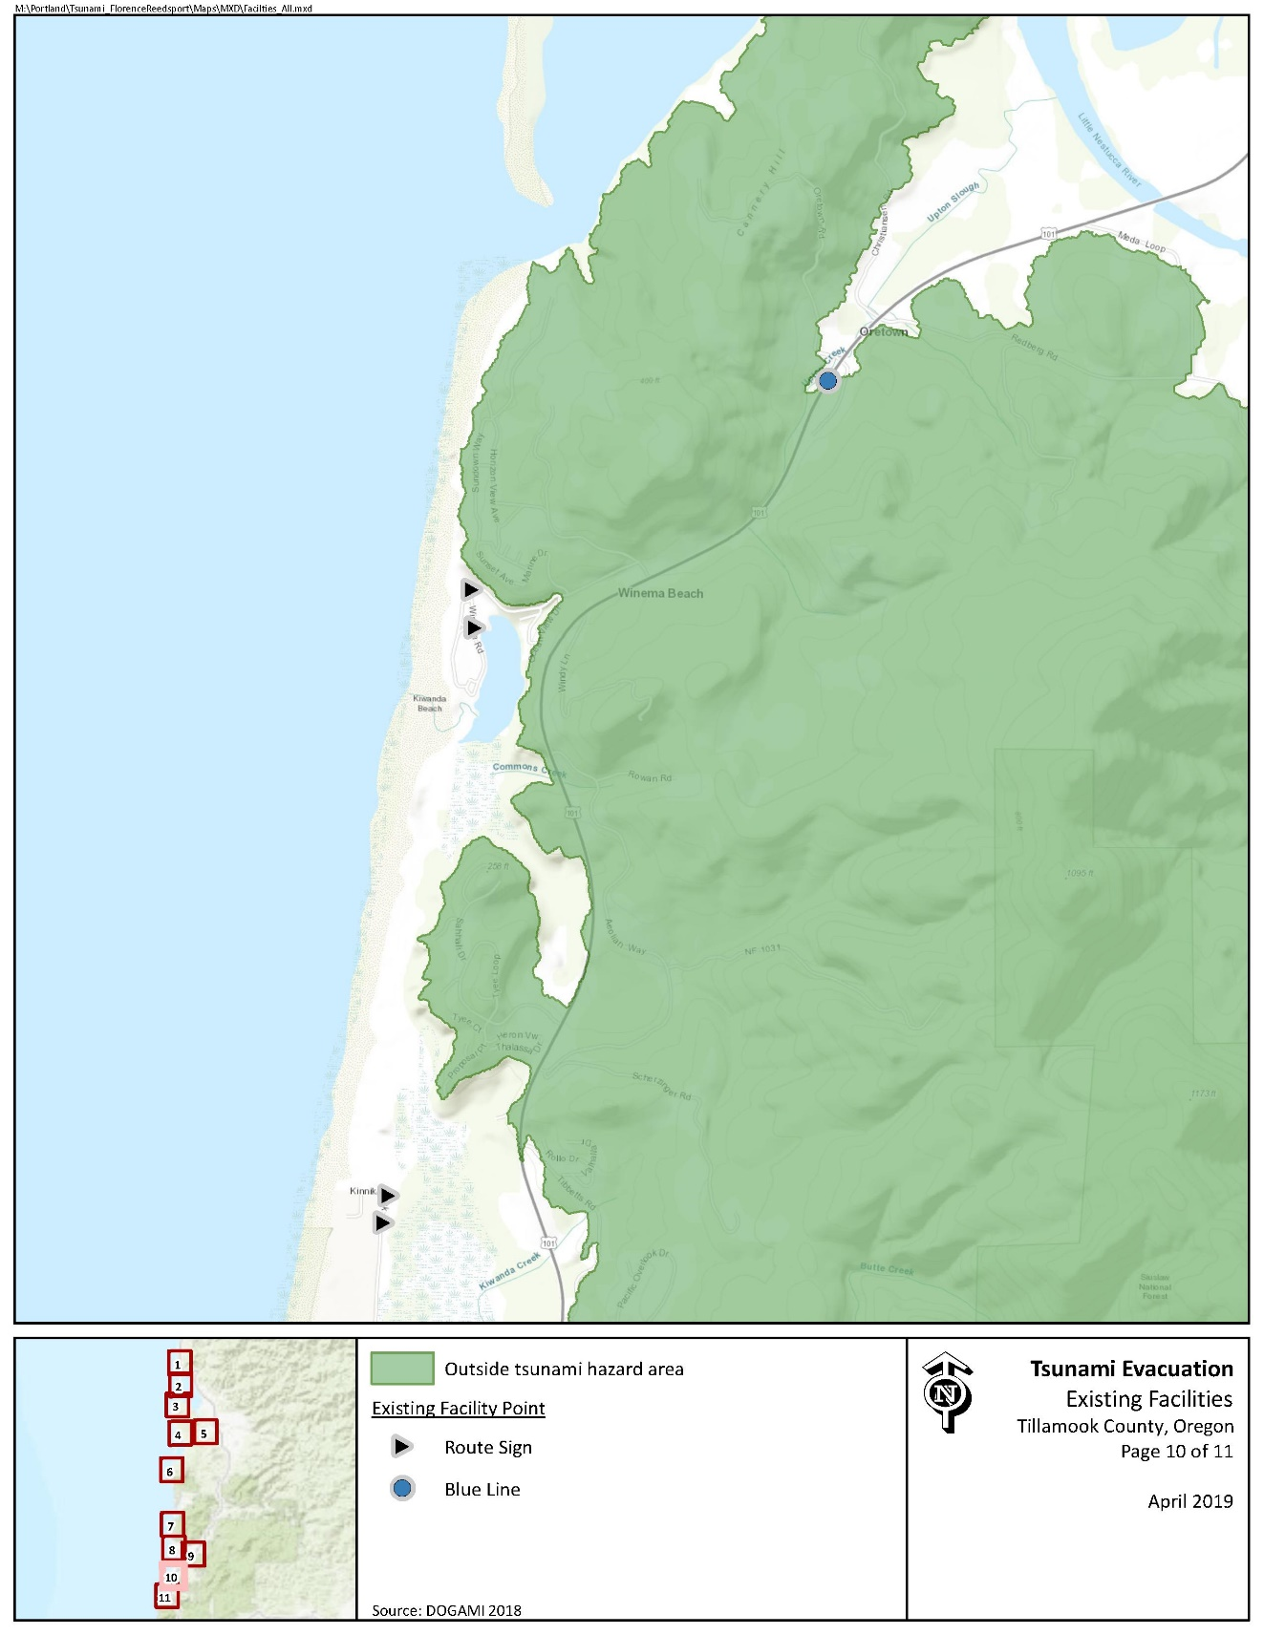

Figure 2 Existing Evacuation Signage – South Beach and Neskowin
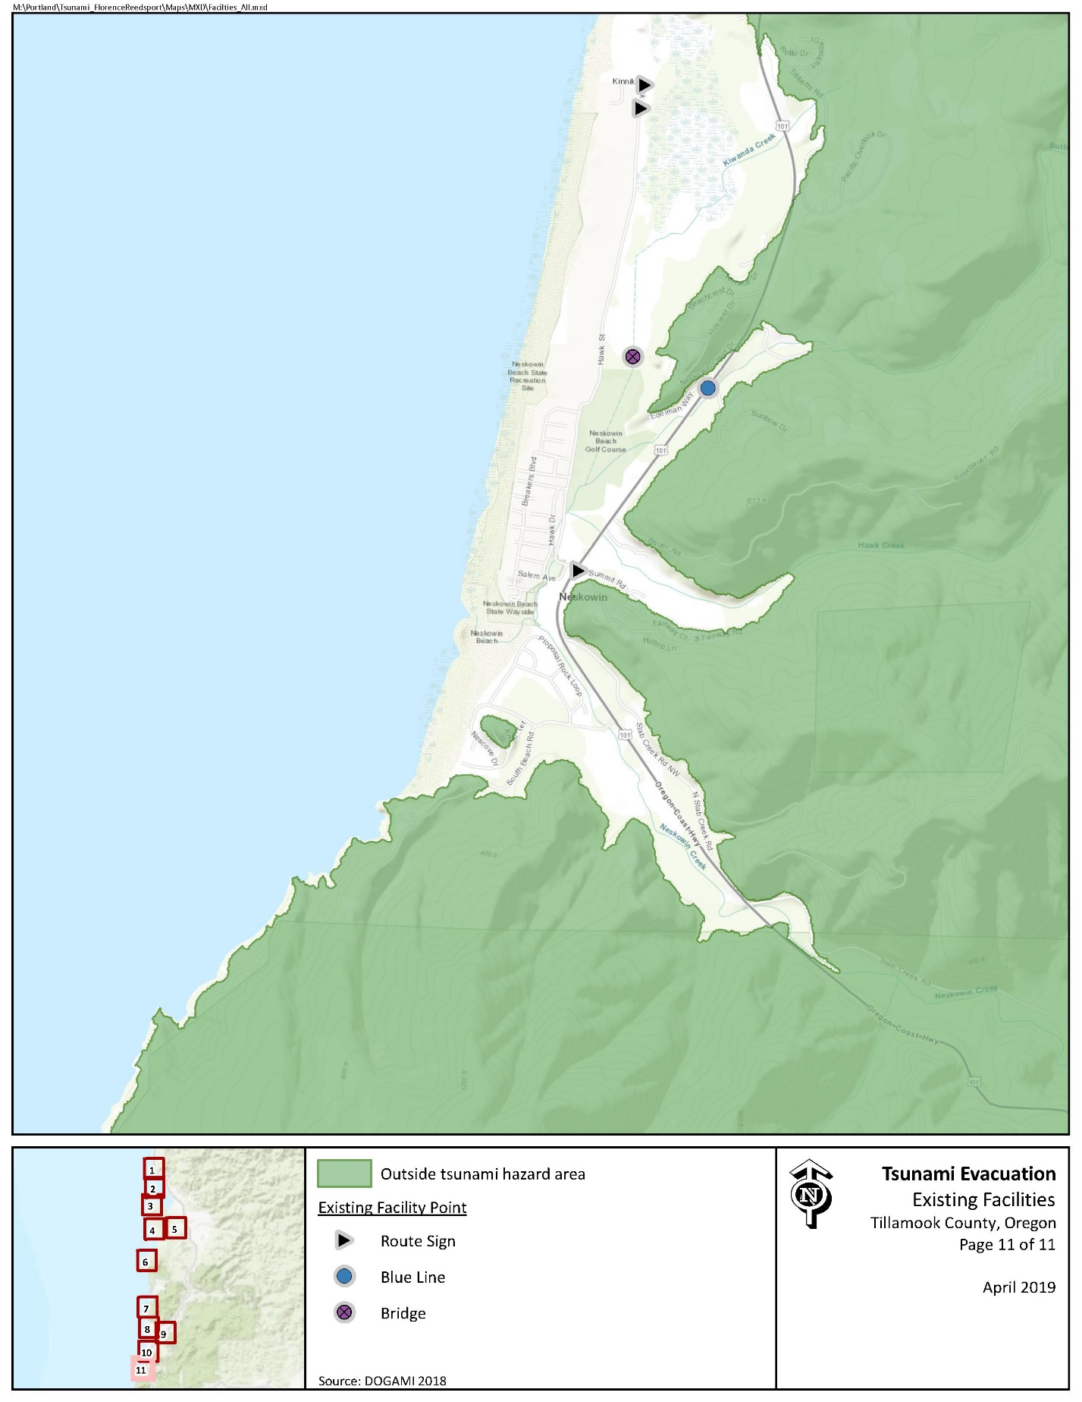

Evacuation Speeds
Evacuation speeds required to reach safety range from a walk to fast walk in much of South Beach and Neskowin. Evacuation speeds along beach access throughout the area requires run, sprint, and unlikely to survive speeds.

Figure 3 Minimum Walking Speeds – North Neskowin and Winema
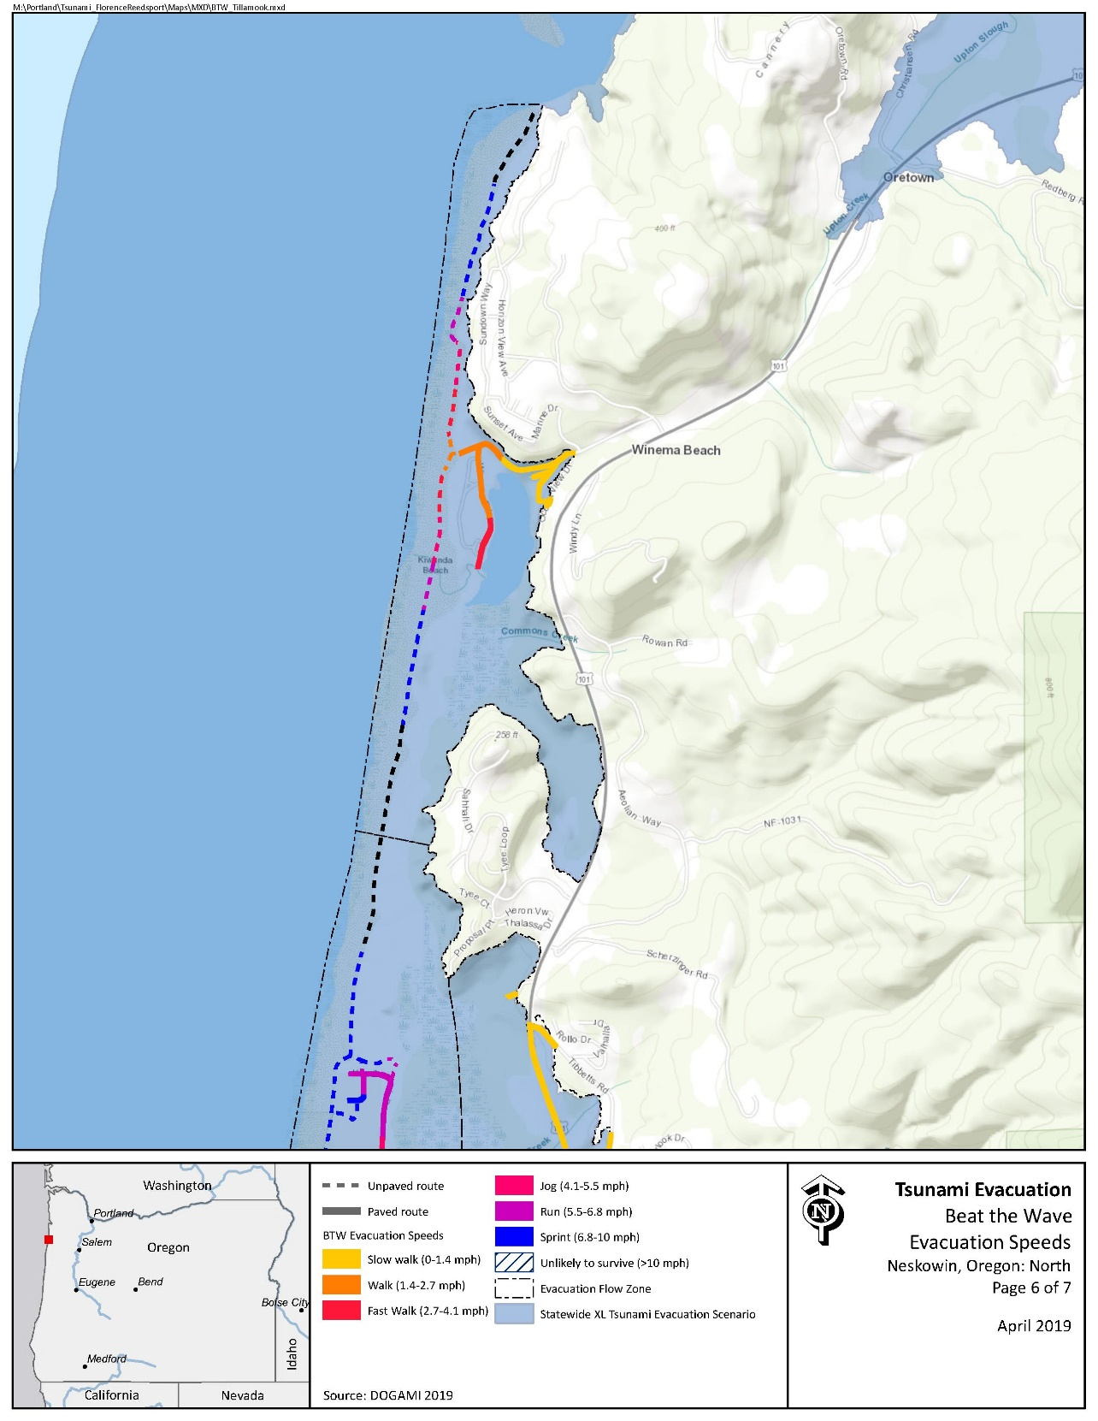
Figure 4 Minimum Walking Speeds – South Beach and Neskowin Proper
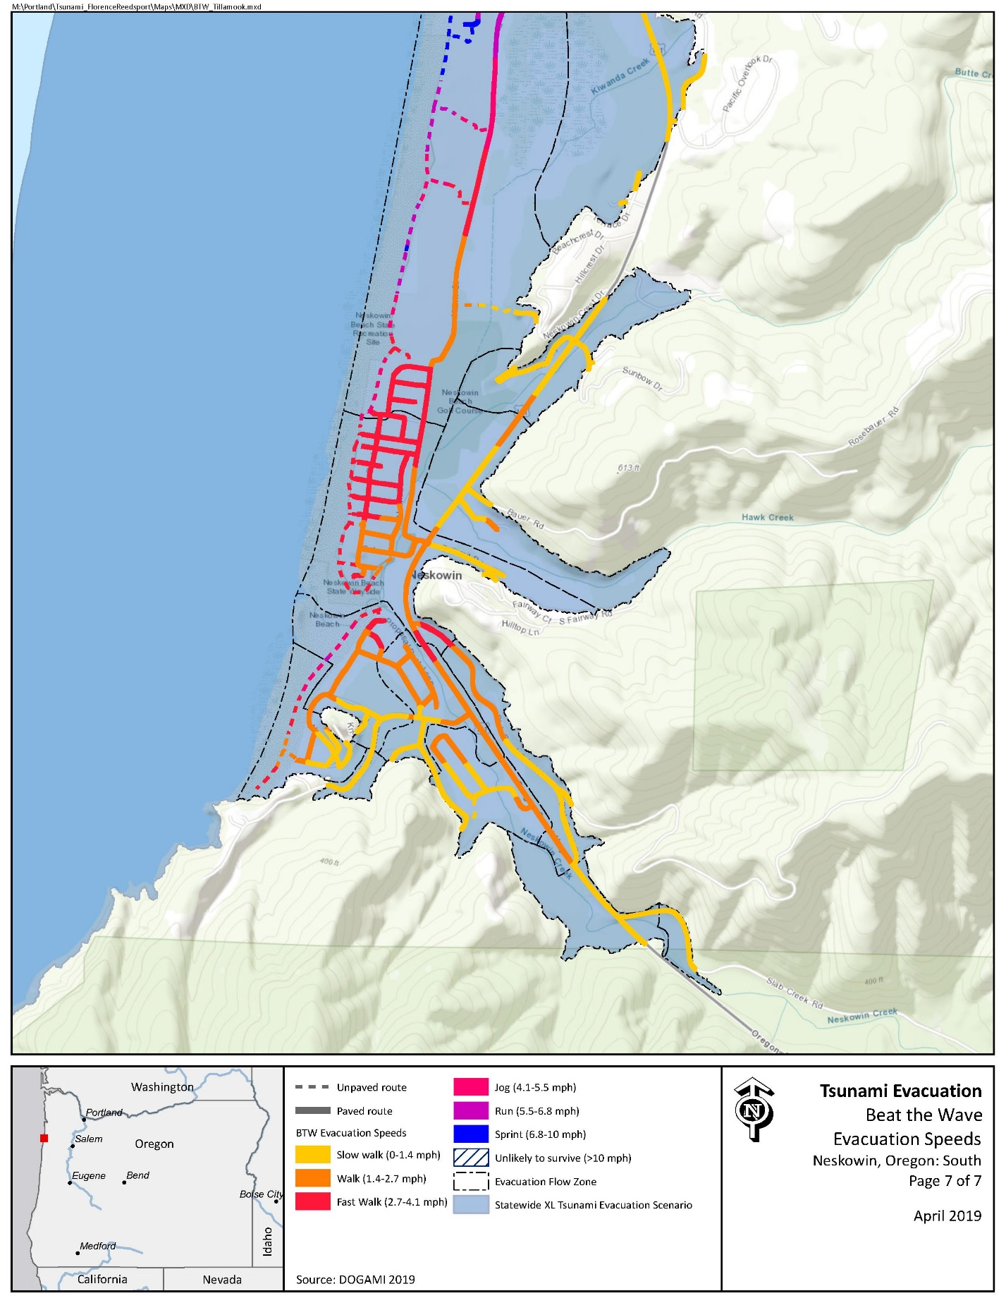

Critical Facilities
Critical facilities within the XXL inundation zone include Nestucca RFPD Neskowin Station #84.

Conclusions
The Neskowin community is characterized by key attributes that may complicate tsunami evacuation. These include the following:
- Large geographic swaths of residential properties within the inundation zone.
- Key infrastructure including the Salem Ave Bridge that may not survive an earthquake.
- Steep terrain along Highway 101 that could slow evacuation and pose the potential for landslides following an earthquake.
The Neskowin community has invested in critical evacuation improvements including the Tsunami Trail and Bridge network that spans Kiwanda Creek. However, additional investment in wayfinding is required to ensure the effective evacuation of residents and visitors.

3 Evacuation Improvements Project Identification

3.1 Wayfinding

The following wayfinding projects have been grouped together under a singular problem statement, as they all attempt to solve a similar issue.
Problem Statement: Limited existing signage and knowledge of priority evacuation routes may present difficulty to residents and visitors in evacuating from the inundation zone.
Prioritized Project Alternatives:
Project ID | Type | Description | Location | Priority | Potential Project Partners | Estimated Cost
4001 | Blue Line | An Existing "Leaving Zone" sign should be relocated north along Highway 101 to this location to ensure it is outside of the XXL scenario. | 45.11289996, -123.9712179 | Medium | ODOT, County Community Development | $138.80 per Blue Line or $147 per aluminum sign plus labor and installation costs
2819 | Blue Line | It is recommended that a Blue Line or “Leaving Zone” sign be placed in Winema Rd just north of Ocean View Dr. | 45.14638747, -123.968173 | Medium | County Public Works, County Community Development
2808 | Map | Recommend tsunami inundation zone map at beach access in South Beach. This site may not be advantageous enough to warrant resource use. | 45.09513868, -123.9877057 | Low | Property owners, County Community Development, DLCD, DOGAMI | $500 per sign
2811 | Map | Recommend tsunami inundation zone map at beach access at Breakers Ave and Carlton Ave. Route signs are not highly effective in grid formats seen in Neskowin and it the placement of a map will help to build awareness in other ways. | 45.14638747, -123.968173 | High
3208 | Route Sign | Recommend route sign placement on South Beach Rd pointing toward Knoll Terrace. | 45.09513868, -123.9877057 | Medium | Property owners, County Community Development, DLCD, DOGAMI | $61 per sign plus labor and installation costs
2809 | Route Sign | Recommend route sign placement pointing south on Knoll Terrace. | 45.096784, -123.983920 | Medium
3206 | Route Sign | Recommend route sign at gate on Nescove Ct toward nearby bluffs. | 45.097696, -123.985849 | High
3202 | Route Sign | Recommend route sign on Highway 101 pointing east onto Redberg Rd. | 45.15673056, -123.9518395 | Medium | ODOT, County Community Development

Potential Funding Sources: Wayfinding projects can often be implemented at minimal cost by utilizing existing, ineffectively-placed signage. However, the NOAA/NWS National Tsunami Hazard Mitigation Program (NTHMP) also provides grants to fund projects throughout coastal communities.
Project Beneficiaries: Wayfinding projects generally support all stakeholders in helping to promote an efficient evacuation process. In particular, residents and visitors benefit from the presence of maps and route signs to institutionalize knowledge.

3.2 Construction
Project ID | Type | Description | Location | Priority | Potential Project Partners | Potential Funding Sources | Estimated Cost | Project  Beneficiaries
1 | Bridge Retrofit | Salem Ave. Bridge has noted deficiencies and its use would greatly improve evacuation effectiveness. It is recommended that the bridge be replaced or retrofit. | 45.10287731, -123.9825277 | High | County Public Works | FEMA HMA, Oregon Transportation Funds | $1.5 million | Residents, visitors, employees
3214 | Road and Bridge Replacement | Road and crossing improvements are in progress on Hawk St south of Amity Ave. Improvements to this location would minimize the need to cross Salem Ave Bridge for high ground. | 45.10579423, -123.9815995 | High | County Public Works |  | TBD
2815 | Trail Enhancement | It is uncertain that the Tsunami Trail Bridge crossing Kiwanda Creek would survive an earthquake. In addition, the bridge is continuously backed up by beaver dams, resulting in deep crossings. It is recommended efforts be made to retrofit the foot bridge. | 45.11245966, -123.9775395 | Medium | Local CAC, County Community Development | Recreational Trail Program, Trails Unlimited | Minimal with volunteer support
1202 | Trail Enhancement | Existing route signage directs evacuees in the north portion of Hawk Street through a field north to Proposal Place. The County has an existing easement in this location, and may need to perform trail enhancements to ensure usability to trail. | 45.124941, -123.976636 | High |  | Recreational Trail Program, Trails Unlimited
3213 | Vertical Evacuation Structure | The effectiveness of the existing evacuation route north to Bull Mountain is unknown at this time. Should this route be unusable, it is recommended that a vertical evacuation structure be considered for the area as no high ground exists within survivable distances. | 45.12686451, -123.9776532 | Low | County Emergency Management, County Community Development | FEMA HMA | $2.5 million

