Community Annex F Oceanside
1 Community Overview 2
2 Existing Evacuation Facilities Analysis 2
3 Evacuation Improvements Project Identification 5
3.1 Wayfinding 5

1 Community Overview
Oceanside is a popular vacation destination, with many residential structures serving as secondary homes and rental properties. The community lies to the south of Cape Meares and to the north of Netarts. Tsunami inundation may be a relatively low concern for the community, as compared with other potential earthquake-related hazards.

2 Existing Evacuation Facilities Analysis

Tsunami Wave Arrival Time
In the XXL scenario, waves will begin to arrive at the beach in approximately 20 minutes after the earthquake begins. The wave crosses the area uniformly and, due to the steep terrain present in Oceanside, minimal land is inundated by the tsunami wave. Nonetheless, inundation is experienced on Netarts Hwy south of Baughman Creek and roadways west of Tillamook Ave and Mountain Rd.
See Appendix B for maps.

Existing Evacuations Routes and Signage
The TEFIP relies on the presence of existing infrastructure and signage to inform improvement planning. While most of the existing signage is accurate, several communities have infrastructure and signage that is either inaccurate or requiring enhancement. The area has existing signage at the following locations (see Figure 1 for location of signs plotted on map):
Type | Description | Recommended Improvement? (X) | Location
Blue Line | Existing “Entering Zone” sign on Pacific Ave approximately 600 feet north of Baughman Creek. This sign is only accurate for a Large scenario and should be considered for replacement. | X – See Project 6002 | 45.459425, -123.968912
 | Existing “Entering Zone sign on Netarts Oceanside Hwy at Breezee Way. This location is well outside of the inundation zone and should be considered for replacement. | X – See Project 821 | 45.45017, -123.959
Route sign | Existing route sign pointing east onto Cape Meares Loop at intersection with Pacific Ave. |  | 45.45769, -123.967
Map | Existing and updated tsunami inundation zone map at parking lot for Oceanside Beach State Recreation Site. |  | 45.46043, -123.970
Vertical Evacuation | There is an existing staircase from the beach to Capes Dr that may allow for vertical evacuation. |  | 45.44904, -123.963

Figure 1 Existing Evacuation Signage
[TO BE INSTERTED IN FINAL DRAFT]

Evacuation Speeds
Evacuation speeds required to reach safety from all roads within the inundation zone are a slow walk. Many of the local beaches require only a slow walk to a walk, but beaches to the northern and southern extents of the Oceanside area may require a run or even sprint.

Figure 2 Minimum Walking Speeds
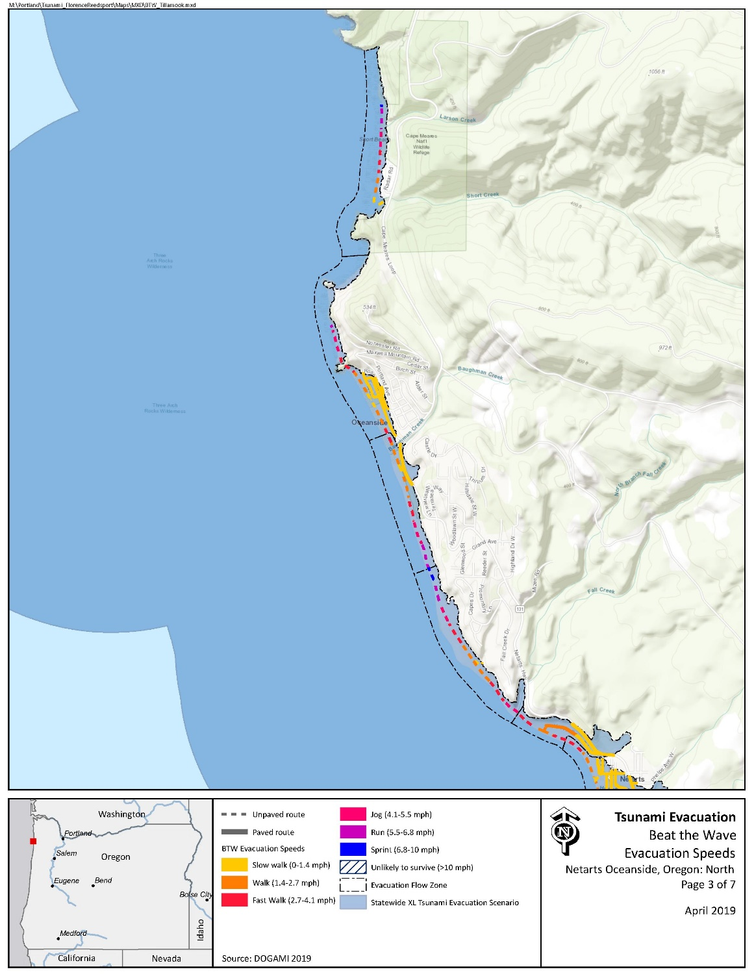

Critical Facilities
No critical facilities exist within the inundation zone.

Conclusions
The Oceanside community benefits from ample high ground, which require relatively slow evacuation speeds. Minimal evacuation improvements are recommended in the area, but several wayfinding and planning projects have been provided for consideration. In addition, the geography surrounding Oceanside (steep slopes and cliffs) are often associated with elevated landslide and ground movement risks. While not directly related to this project, a potential landslide could greatly impact residents/ and visitors’ ability to safely evacuate.

3 Evacuation Improvements Project Identification

3.1 Wayfinding

The following wayfinding projects have been grouped together under a singular problem statement, as they all attempt to solve a similar issue.
Problem Statement: Limited existing signage and knowledge of priority evacuation routes may present difficulty to residents and visitors in evacuating from the inundation zone.
Prioritized Project Alternatives:
Project ID | Type | Description | Location | Priority | Potential Project Partners | Estimated Cost
6002 | Blue Line | Existing “Entering Zone” sign on Pacific Ave approximately 600 feet north of Baughman Creek. This sign is only accurate for a Large scenario and should be considered for replacement at accurate location. | 45.458084, -123.968019 | High | County Community Development, County Public Works, DLCD, DOGAMI | $138.80 per Blue Line or $147 per aluminum sign plus labor and installation costs
6003 | Blue Line | Existing “Entering Zone sign on Netarts Oceanside Hwy at Breezee Way. This location is well outside of the inundation zone and should be considered for replacement at accurate location to the north. | 45.455209, -123.966603 | Medium
4813 | Blue Line | Recommend placement of Blue Line on Rosenburg Loop outside of XXL inundation zone. Rosenburg Loop is only outside of the inundation zone in the northeast corner of the loop and this location may benefit from multiple blue lines. | 45.461771, -123.969950 | High
6004 | Blue Line | (Associated with Project 4813) Recommend placement of Blue Line on Rosenburg Loop outside of XXL inundation zone. Rosenburg Loop is only outside of the inundation zone in the northeast corner of the loop and this location may benefit from multiple blue lines. | 45.462049, -123.970937 | High
4814 | Blue Line | Recommend placement of Blue Line on Maxwell Mountain Rd outside of XXL inundation zone. | 45.461298, -123.969453 | Medium

Potential Funding Sources: Wayfinding projects can often be implemented at minimal cost by utilizing existing, ineffectively-placed signage. However, the NOAA/NWS National Tsunami Hazard Mitigation Program (NTHMP) also provides grants to fund projects throughout coastal communities.
Project Beneficiaries: Wayfinding projects generally support all stakeholders in helping to promote an efficient evacuation process. In particular, residents and visitors benefit from the presence of maps and route signs to institutionalize knowledge.

