Community Annex G Pacific City/Woods
1 Community Overview 2
2 Existing Evacuation Facilities Analysis 2
3 Evacuation Improvements Project Identification 4
3.1 Wayfinding 4
3.2 Planning 7
3.3 Construction 7

1 Community Overview
The Pacific City/Woods area extends south from Cape Kiwanda State Natural Area to Bob Straub State Park and Nestucca Bay National Wildlife Refuge in the southern extent. The area within the inundation zone has a mix of commercial and residential uses.

2 Existing Evacuation Facilities Analysis

Tsunami Wave Arrival Time
In the XXL scenario, waves will begin to arrive at the beach in approximately 18-20 minutes after the earthquake begins. The vast majority of the planning area would be inundated within 25 minutes, while Hill Road and Woods would be inundated within 27 minutes. The tsunami will also travel upstream on the Nestucca River, ultimately reaching the community of Meda in approximately 50 minutes.
See Appendix B for maps.

Existing Evacuations Routes and Signage
The TEFIP relies on the presence of existing infrastructure and signage to inform improvement planning. While most of the existing signage is accurate, several communities have infrastructure and signage that is either inaccurate or requiring enhancement. The area has existing signage at the following locations (see Figure 1 for location of signs plotted on map):
Type | Description | Recommended Improvement? (X) | Location
Blue Line | Existing “Entering Zone” sign on Highway 101 south of Cloverdale. |  | 45.19187, -123.9
Route Sign | Existing route sign on Brooten Rd pointing onto Fischer Rd facing south. |  | 45.19588, -123.957
 | Existing route signs (two signs) on Pacific Ave pointing north and south onto Brooten Rd. |  | 45.20184, -123.962
 | Existing route sign at Cape Kiwanda Dr and Pacific Ave pointing across Pacific Ave Bridge. The community may want to consider other routes that do not require bridge passage. | X – See Project 2401 | 45.20223, -123.966
 | Existing route sign on Cape Kiwanda Dr pointing east onto Nestucca Ridge Rd. |  | 45.20895, -123.966
 | Existing route sign on Brooten Rd pointing toward Bayshore Medical Pacific City. |  | 45.17949, -123.927
 | Small route sign at Cape Kiwanda State Park parking lot pointing north on Highway 101. |  | 45.21552, -123.97
 | Existing route sign on Sandlake Rd north of A St in Pacific Woods. |  | 45.21561, -123.955
 | Existing route sign on McPhillips Dr pointing east onto Pine Drive. This area is well outside of the inundation zone and should be considered for removal or replacement. | X – See Project 4810 | 45.22182, -123.969
Vertical Evacuation | Existing sand dune in Cape Kiwanda State Park that provides access to high ground. |  | 45.21552, -123.97
Trail System | Existing trail system in north portion of Bob Straub State Park, which leads to high ground during L scenario. |  | 45.19387, -123.967

Figure 1 Existing Evacuation Signage
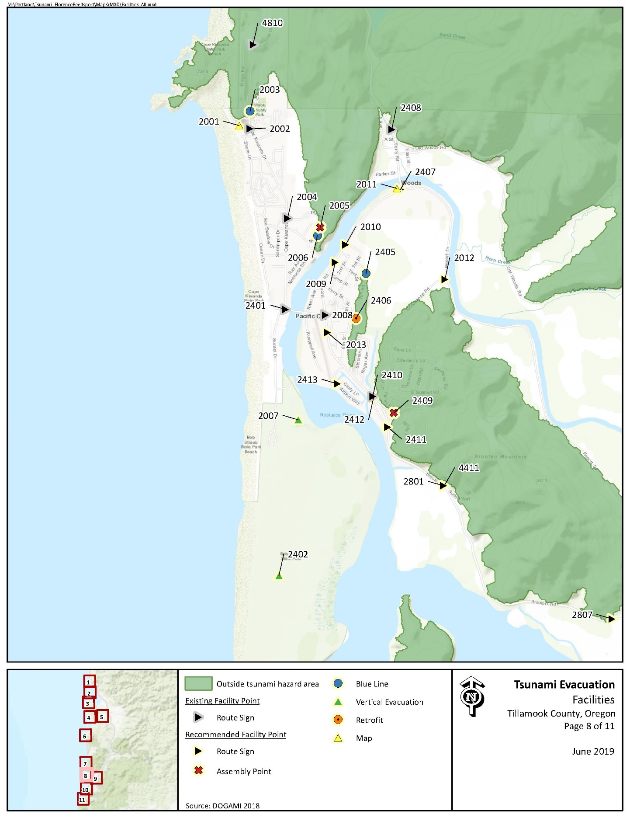

Evacuation Speeds
Evacuation speeds required to reach safety from all roads within the inundation zone range from slow walk to fast walk. Many of the local beaches as well as areas within Bob Straub State Park may require a run or even sprint.

Figure 2 Minimum Walking Speeds
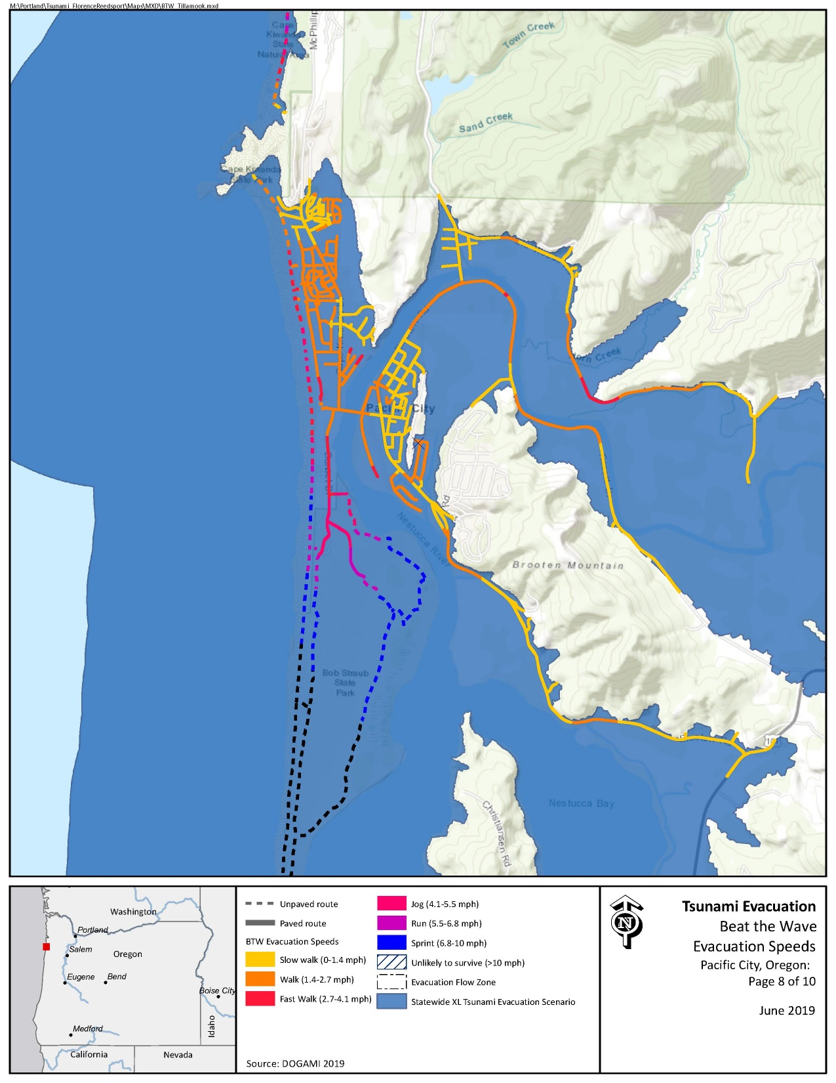

Critical Facilities
Critical facilities within the inundation zone include The Nestucca RFPD Pacific City Station #82

Conclusions
The Pacific City/Woods community benefits from ample high ground, which require relatively slow evacuation speeds. However, additional signage and wayfinding infrastructure is recommended to ensure awareness of residents and visitors. In addition, several locations within the area are remote and far from high ground (such as Bob Straub State Park) and may benefit from vertical evacuation strategies.

3 Evacuation Improvements Project Identification

3.1 Wayfinding

The following wayfinding projects have been grouped together under a singular problem statement, as they all attempt to solve a similar issue.
Problem Statement: Limited existing signage and knowledge of priority evacuation routes may present difficulty to residents and visitors in evacuating from the inundation zone.
Prioritized Project Alternatives:
Project ID | Type | Description | Location | Priority | Potential Project Partners | Estimated Cost
2401 | Route Prioritization | Existing route sign at Cape Kiwanda Dr and Pacific Ave pointing across Pacific Ave Bridge. The community may want to consider other routes that do not require bridge passage. | 45.202248, -123.965914 | High | Residents, County Community Development, DLCD | Minimal – in-kind time and support
4810 | Route Sign | Existing route sign on McPhillips Dr pointing east onto Pine Rd. This area is well outside of the inundation zone and should be considered for removal or replacement. | 45.221680, -123.969545 | Low | County Community Development, County Public Works, DLCD, DOGAMI | $61 per sign plus labor and installation costs
2409 | Assembly Point | Recommend placement of Assembly Point sign in empty parking area on Fischer Rd near Solita Blvd. | 45.19469187, -123.9543615 | Medium | Local residents, County Community Development, County Public Works, DLCD, DOGAMI | $60 per sign plus labor and installation costs
2005 | Assembly Point | Existing route signs direct evacuees east onto Nestucca Ridge Rd, but no Assembly Point signs are present. It is recommended that the community coordinate with residents to establish signage, as local residents have not been receptive to similar projects in the past. | 45.2083174, -123.962287 | Low
2405 | Blue Line | Recommend placement of Blue Line or “Leaving/Entering Zone” sign on northern extent of Hill Rd outside of inundation zone. This area represents limited accessible high ground for surrounding properties and must be accompanied by signage. | 45.20493077, -123.9574483 | Medium | County Community Development, County Public Works, DLCD, DOGAMI | $138.80 per Blue Line or $147 per aluminum sign plus labor and installation costs
2006 | Blue Line | (Associated with Project 2005). Existing route signs direct evacuees east onto Nestucca Ridge Rd, but no Blue Lines or “Entering/Leaving Zone” signs are present. It is recommended that the community coordinate with residents to establish signage, as local residents have not been receptive to similar projects in the past. Blue Lines should be placed on northern and southern portions of Nestucca Ridge Rd at XXL inundation lines. | 45.20769677, -123.9625822 | Low
2003 | Blue Line | Recommend placement of Blue Line or “Entering/Leaving Zone” signs on McPhillips Dr/Cape Kiwanda Dr at XXL inundation line north of Circle Dr. | 45.21680753, -123.969774 | Medium
2001 | Map | Recommend placement of tsunami inundation zone map at parking lot for Cape Kiwanda State Park. This will promote awareness and education to visitors who may be unaware of the tsunami risks in the area. | 45.21574899, -123.9709178 | High | County Community Development, Oregon State Parks, County Public Works, DLCD, DOGAMI | $500 per sign
2807 | Route Sign | Recommend placement of route signs on Brooten Ave north onto unnamed road to Pacific City Transfer Station. This location is outside of the XXL inundation zone and may provide easier access than the Bayshore Medical Center. | 45.17968252, -123.9312592 | Low | County Community Development, County Public Works, DLCD, DOGAMI | $61 per sign plus labor and installation costs
2801 | Route Sign | Recommend placement of route signs (two signs) on Brooten Rd facing north and south, directing evacuees east onto Sutton Way. | 45.18936324, -123.9490709 | High
2411 | Route Sign | (Associated with Project 2412) Recommend placement of route sign at Nestucca Manor Dr and Brooten Rd directing evacuees north on Brooten Rd toward Fischer Rd. | 45.19363203, -123.9549896 | High
2412 | Route Sign | (Associated with Project 2411) Recommend placement of route sign facing north directing evacuees east onto Fischer Rd. Currently, only route signage facing south exists at Fischer Rd. | 45.19577131, -123.9564979 | High
2413 | Route Sign | Recommend route sign at intersection of Cindy Ln and Airport Way near the intersection. Numerous residential properties are present in this location and presence of Bob Straub State Park may confuse residents and visitors regarding the risk of tsunami inundation. | 45.19679084, -123.9603158 | Medium | County Community Development, County Public Works, County Parks, DLCD, DOGAMI | $61 per sign plus labor and installation costs
2013 | Route Sign | Recommend placement of route sign on Brooten Rd directing evacuees east onto Haystack St toward Hill Rd. | 45.20056304, -123.9614057 | Medium
2012 | Route Sign | Existing route sign at Resort Dr and Reddekopp Rd is missing an arrow identifying the direction evacuees should travel. Recommended maintenance to update route sign with arrow pointing west onto Reddekopp Rd. | 45.20459116, -123.9491645 | High
2009 | Route Sign | Recommend placement of route sign on Brooten Rd directing evacuees east onto Tent St toward Hill Rd. Project may also require placement of route signs on 3rd St and Tent St and 3rd St and Hill Rd. | 45.20574, -123.9606773 | Medium
2010 | Route Sign | Recommend placement of route sign on Brooten Rd directing evacuees east onto Spring St. Project may also require placement of route sign at 3rd and Hill Rd. (Associated with Project 2009) | 45.20705821, -123.9596137 | High
2407 | Route Sign | Recommend placement of route sign on Brooten Rd/Resort Dr directing evacuees north onto Ferry St. This location is on Woods County Campground/Park grounds, which would ease feasibility, as it is County property. | 45.21116942, -123.9539294 | High
2011 | Map | (Associated with Project 2407). Recommend placement of tsunami inundation zone map in Woods County Campground/Park, which would ease feasibility, as it is County property. | 45.21116942, -123.9539294 | High | County Community Development, County Public Works, DLCD, DOGAMI | $500 per sign

Potential Funding Sources: Wayfinding projects can often be implemented at minimal cost by utilizing existing, ineffectively-placed signage. However, the NOAA/NWS National Tsunami Hazard Mitigation Program (NTHMP) also provides grants to fund projects throughout coastal communities.
Project Beneficiaries: Wayfinding projects generally support all stakeholders in helping to promote an efficient evacuation process. In particular, residents and visitors benefit from the presence of maps and route signs to institutionalize knowledge.

3.2 Planning
Project ID | Type | Description | Location | Priority | Potential Project Partners | Potential Funding Sources | Estimated Cost
2406 | Engineering Study | The community may wish to seek a seismic and landslide susceptibility study to be performed near Hill Rd. This location will likely serve as the nearest high ground for a large segment of the population, and additional studies are needed to determine its survivability. | 45.202745, -123.958125 | Medium | County Community Development, DOGAMI, DLCD | General budget, FEMA PDM | $100,000
2401 | Engineering Study | Existing route sign at Cape Kiwanda Dr and Pacific Ave pointing across Pacific Ave Bridge. It may be valuable to have a seismic study performed on the bridge to determine its likelihood to survive the earthquake. Based on the findings, a retrofit or bridge replacement may be warranted. | 45.202248, -123.965914 | Medium | County Community Development, DOGAMI, DLCD | General budget, FEMA PDM | $100,000

3.3 Construction
Project ID | Type | Description | Location | Priority | Potential Project Partners | Potential Funding Sources | Estimated Cost
2402 | Vertical Evacuation | The community and State may want to consider placement of a vertical evacuation structure in the south/central portion of Bob Straub State Park. This area is considered “unlikely to survive” for evacuation purposes. | 45.182482, -123.966193 | Low | County Community Development, Oregon State Parks, DLCD, DOGAMI | NTHMP, FEMA HMA | $2.5 million
2007 | Vertical Evacuation | This location within Bob Straub State Park has an existing trail to high ground under a Large scenario. However, the community may want to consider the value of a vertical evacuation structure placed in existing Large scenario high ground that is capable of surviving an XXL scenario. | 45.194066, -123.964434 | Medium |  |  | $2.5 million

