Community Annex H Sand Lake
1 Community Overview 2
2 Existing Evacuation Facilities Analysis 2
3 Evacuation Improvements Project Identification 4
3.1 Wayfinding 4

1 Community Overview
The Sand Lake area encompasses the entirety of the Sand Lake estuary including Whalen Island and the Sand Lake Recreational Area. The low-lying region contains large swaths of land within the inundation zone, but relatively few structures. The area is also a popular destination for camping and recreational activities.

2 Existing Evacuation Facilities Analysis

Tsunami Wave Arrival Time
In the XXL scenario, waves will begin to arrive at the beach in approximately 20 minutes after the earthquake begins. The wave will then arrive at Whalen Island within 24 minutes and inundate the entire zone within 34 minutes.
See Appendix B for maps.

Existing Evacuations Routes and Signage
The TEFIP relies on the presence of existing infrastructure and signage to inform improvement planning. While most of the existing signage is accurate, several communities have infrastructure and signage that is either inaccurate or requiring enhancement. The area has existing signage at the following locations (see Figure 1 for location of signs plotted on map):
Type | Description | Recommended Improvement? (X) | Location
Blue Line | Existing “Leaving Zone” sign on Galloway Rd west of Derrick Rd at XXL inundation zone line. |  | 45.3035, -123.943
Route Sign | Existing route sign in eastern parking lot for Sand Lake ATV site. Sign is partially obscured and points north, as opposed to the closest high ground, which is directly east. | X – See Project 4401 | 45.2879, -123.956
 | Existing route sign in western parking lot for Sand Lake ATV site. Sign is partially obscured and points north, as opposed to the closest high ground, which is directly east. | X – See Project 4802 | 45.2879, -123.958
 | Existing route sign in western parking lot for Sand Lake ATV site, along Galloway Rd. Sign points north. |  | 45.286, -123.958
 | Existing route sign at entrance to Whalen Island State Park, directing evacuees east across bridge toward Sandlake Rd. |  | 45.273, -123.949
 | Existing route sign at exit for Sandbeach Campground (U.S. Parks) pointing north toward Galloway Rd. |  | 45.284, -123.955
Map | Existing, but outdated tsunami inundation zone map in Sandbeach Campground. Recommended replacement of map. | X – See Project 4801 | 45.284, -123.955
 | Existing, updated tsunami inundation zone map in Clay Myers State Natural Area campground near restrooms. |  | 45.273, -123.950

Figure 1 Existing Evacuation Signage
[UPDATED MAP TO BE INCLUDED IN FINAL DRAFT]

Evacuation Speeds
Evacuation speeds required to reach safety vary from slow walk to run across the area. Nearly all areas excluding the Sand Lake Recreation Area can evacuate at slow walk or walk speeds. Within the Sand Lake Recreation Area, speeds of run may be necessary to reach high ground.

Figure 2 Minimum Walking Speeds
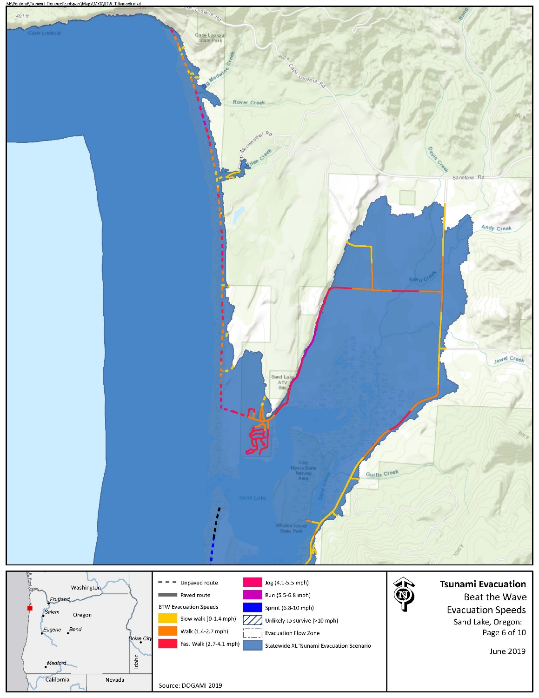

Critical Facilities
No critical facilities exist within the inundation zone.

Conclusions
The Sand Lake community has sufficient high ground in most areas. Additional signage and awareness campaigns will be critical in ensuring visitors are well-informed of tsunami risks in the area.

3 Evacuation Improvements Project Identification

3.1 Wayfinding

The following wayfinding projects have been grouped together under a singular problem statement, as they all attempt to solve a similar issue.
Problem Statement: Limited existing signage and knowledge of priority evacuation routes may present difficulty to residents and visitors in evacuating from the inundation zone.
Prioritized Project Alternatives:
Project ID | Type | Description | Location | Priority | Potential Project Partners | Estimated Cost
4403 | Assembly Point | Recommend placement of Assembly Point sign in sheltered area of high grounds along dunes at the Sand Lake ATV Site. | 45.28925, -123.954715 | Medium | U.S. Forest Service, County Community Development | $60 per sign plus labor and installation costs
4401 | Route Sign | Existing route sign in eastern parking lot for Sand Lake ATV Site. Sign is partially obscured and points north, as opposed to the closest high ground, which is directly east. | 45.2879, -123.956 | High |  | $61 per sign plus labor and installation costs
4802 | Route Sign | Existing route sign in western parking lot for Sand Lake ATV Site. Sign is partially obscured and points north, as opposed to the closest high ground, which is directly east. | 45.2879, -123.958 | High
4404 | Map | Recommend placement of tsunami inundation zone map in western parking lot for Sand Lake ATV Site. Location will promote awareness and education among visitors who may be unfamiliar of the tsunami risk. | 45.286874, -123.958406 | Medium |  | $500 per sign
4801 | Map | Recommend update of existing tsunami inundation zone map in the Sandbeach Campground. The existing map has degraded and is difficult to interpret. The updated map should illustrate the XXL scenario. | 45.284081, -123.955326 | High
4818 | Blue Line | Sandlake Rd presents many difficulties in reaching high ground as much of the area including the roadway and west are within the XXL inundation zone. However, under a Large scenario, portions of Sandlake Rd may not be fully inundated. The community should consider placement of Blue Lines or “Entering/Leaving Zone” signs along Sandlake Rd to illustrate locations that are potentially survivable. If this action is not taken, additional signage is required throughout the Sandlake Rd region north to Galloway Rd and south to Tierra del Mar to ensure adequacy of awareness and education. | 45.279414, -123.93948 | Low/High | County Community Development | $138.80 per Blue Line or $147 per aluminum sign plus labor and installation costs
4806 | Map | No existing infrastructure or signage exists at Sitka State Natural Area. It is recommended that the community consider placement of a tsunami inundation zone map to build awareness and education. | 45.279414, -123.93948 | Medium | Oregon State Parks | $500 per sign

Potential Funding Sources: Wayfinding projects can often be implemented at minimal cost by utilizing existing, ineffectively-placed signage. However, the NOAA/NWS National Tsunami Hazard Mitigation Program (NTHMP) also provides grants to fund projects throughout coastal communities.
Project Beneficiaries: Wayfinding projects generally support all stakeholders in helping to promote an efficient evacuation process. In particular, residents and visitors benefit from the presence of maps and route signs to institutionalize knowledge.

