Community Annex I Tierra Del Mar
1 Community Overview 2
2 Existing Evacuation Facilities Analysis 2
3 Evacuation Improvements Project Identification 4
3.1 Wayfinding 4
3.2 Planning 5
3.3 Construction 5

1 Community Overview
The Tierra Del Mar community occupies a small stretch of land centered along Sandlake Rd and the Pacific Ocean. Tierra Del Mar is south of the Sand Lake Estuary and north of Cape Kiwanda State Natural Area. The area is almost exclusively residential and numerous residential structures are within the XXL inundation zone.

2 Existing Evacuation Facilities Analysis

Tsunami Wave Arrival Time
In the XXL scenario, waves will begin to arrive at the beach in approximately 20 minutes after the earthquake begins. The wave crosses the area uniformly and ends east of Sandlake Rd.
See Appendix B for maps.

Existing Evacuations Routes and Signage
The TEFIP relies on the presence of existing infrastructure and signage to inform improvement planning. While most of the existing signage is accurate, several communities have infrastructure and signage that is either inaccurate or requiring enhancement. The area has existing signage at the following locations (see Figure 1 for location of signs plotted on map):
Type | Description | Recommended Improvement? (X) | Location
Route Sign | Existing route sign on Sandlake Rd pointing east toward unnamed gravel road. Sign is located at Welcome to Tierra Del Mar sign. |  | 45.2566, -123.961
 | Existing route sign on Sandlake Rd pointing east onto Jasmine Ave. |  | 45.2546, -123.9629
 | Existing route sign on Sandlake Rd pointing east onto Austin Ave. |  | 45.2526, -123.9643
 | Existing route sign on Sandlake Rd pointing east onto Floyd Ave. |  | 45.2500, -123.9654
 | Existing route sign on Sandlake Rd pointing east onto Harris Ave. |  | 45.249, -123.9660

Figure 1 Existing Evacuation Signage
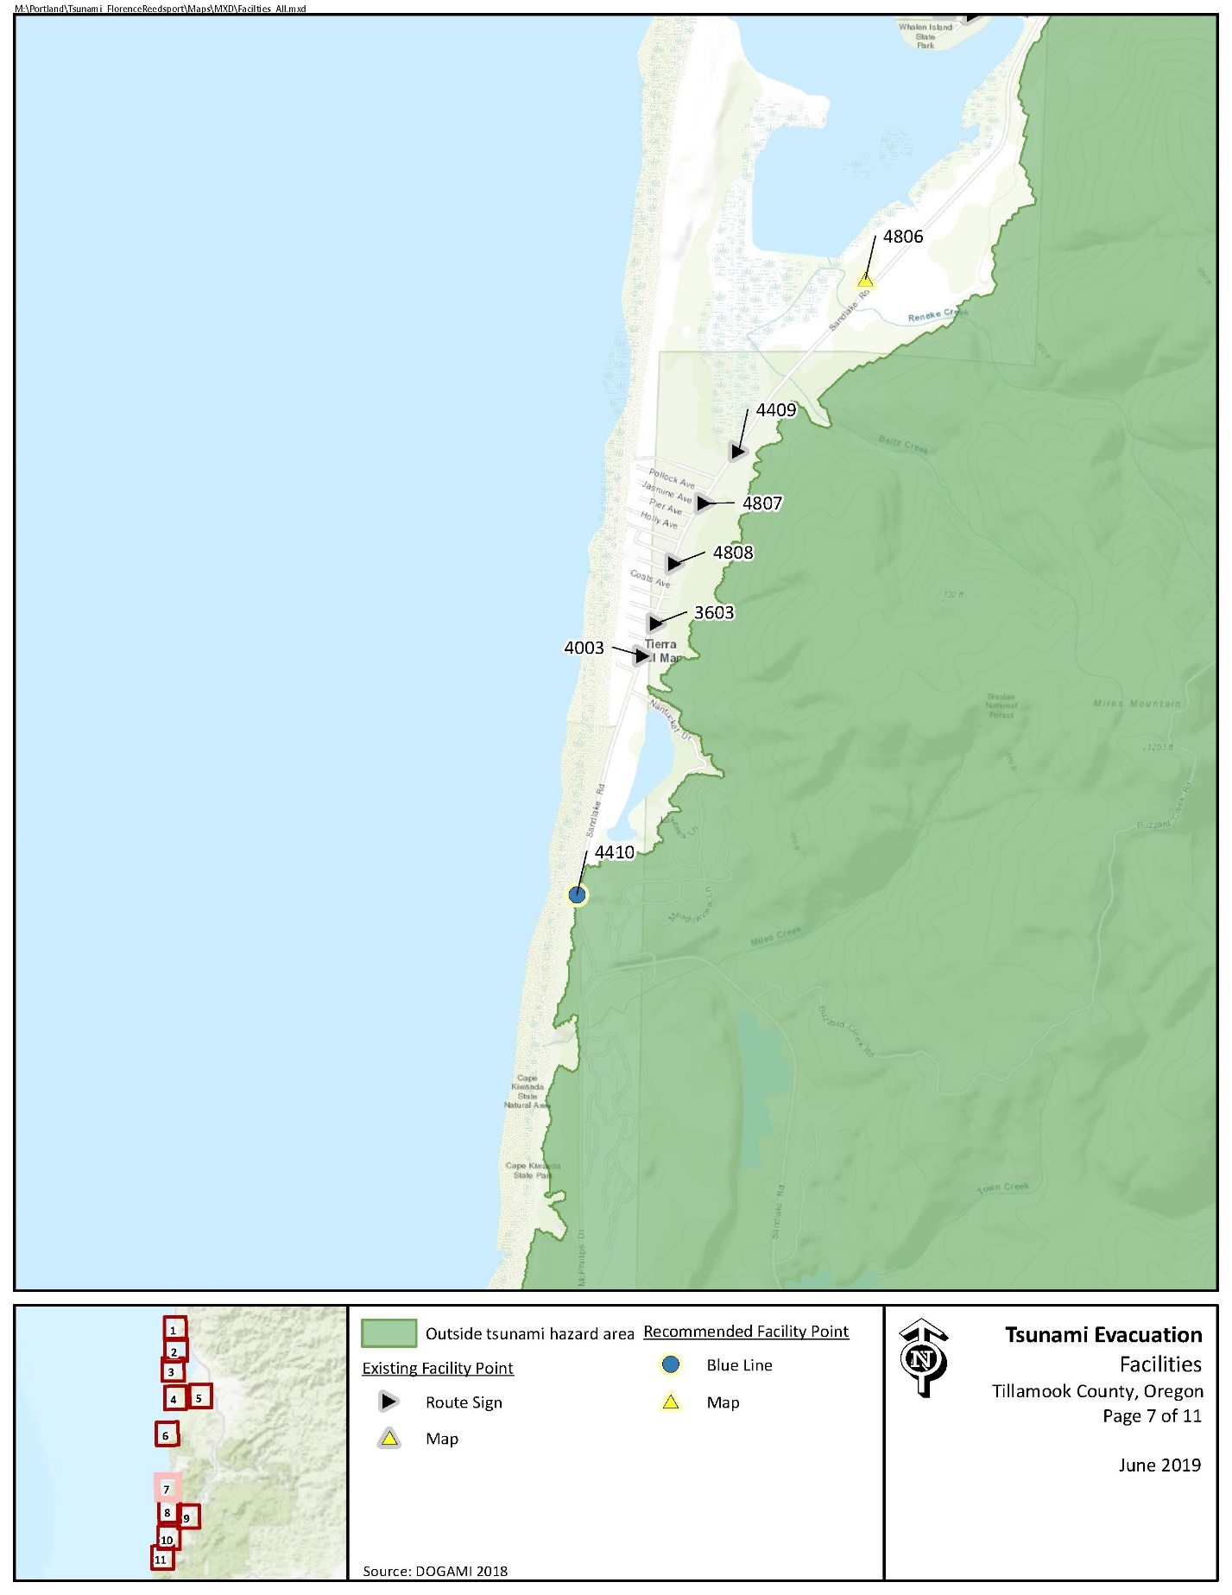

Evacuation Speeds
Evacuation speeds required to reach safety largely increase across the board the closer the evacuee is to the coastline. Required speeds vary from walk to fast walk utilizing the existing road network and fast walk to job under a scenario in which liquefaction impacts the road network following the earthquake.

Figure 2 Minimum Walking Speeds
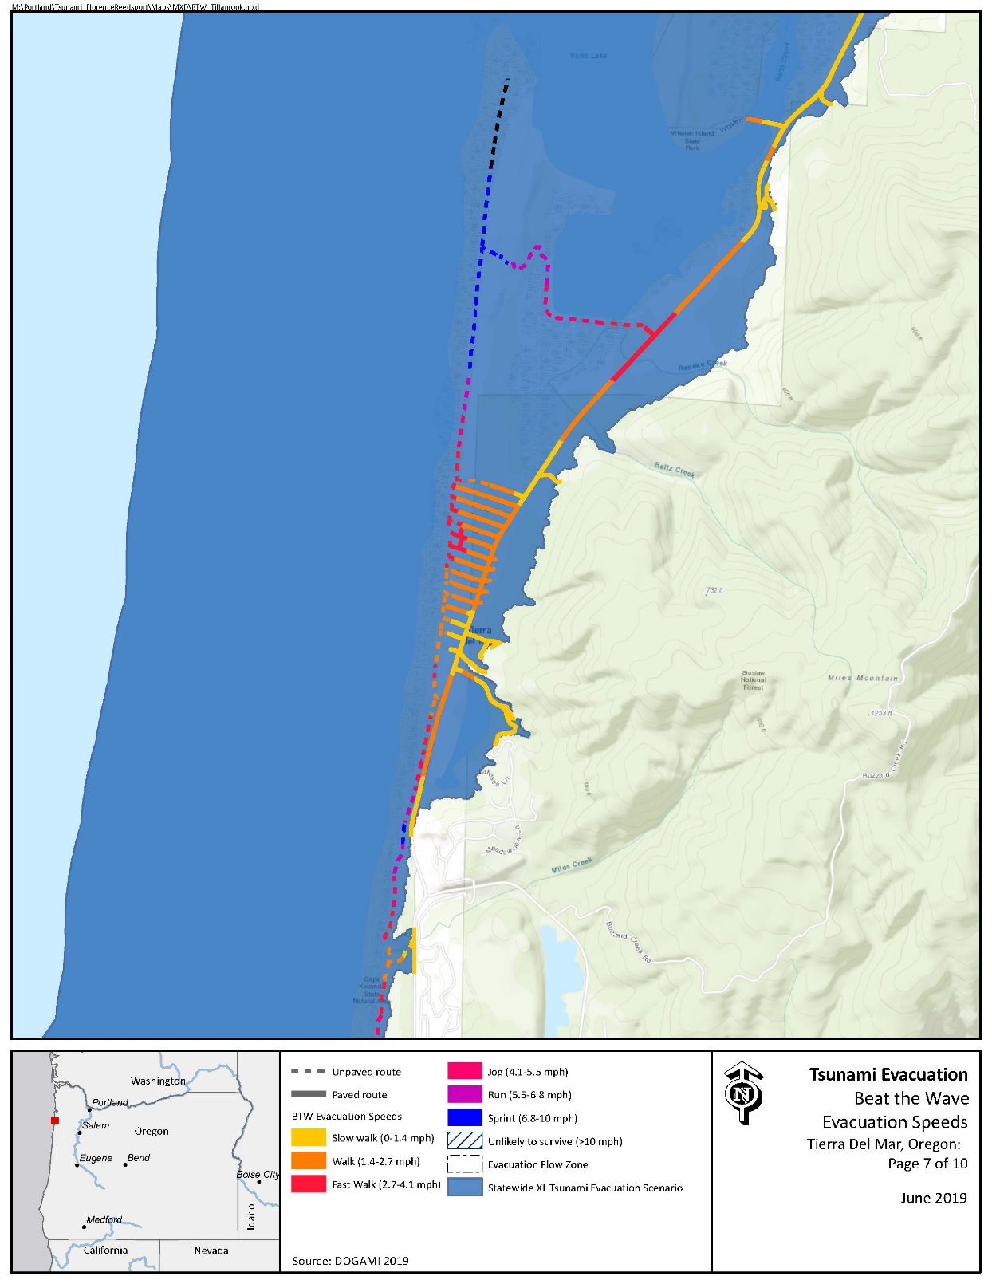

Critical Facilities
No critical facilities exist within the inundation zone.

Conclusions
The Tierra Del Mar community benefits from ample existing route signage and an east to west road network providing ample opportunity to reach high ground. The community should not find it necessary to add additional route signage, but may benefit from the placement of tsunami inundation zone maps and Blue Lines or “Entering/Leaving Zone” signs. While not directly related to the scope of this project, many residential homes are well within the inundation zone on the west side of Sandlake Rd. Public education and awareness materials should be provided to residents and guests to ensure awareness of the tsunami risk in their area.

3 Evacuation Improvements Project Identification

3.1 Wayfinding

The following wayfinding projects have been grouped together under a singular problem statement, as they all attempt to solve a similar issue.
Problem Statement: Limited existing signage and knowledge of priority evacuation routes may present difficulty to residents and visitors in evacuating from the inundation zone.
Prioritized Project Alternatives:
Project ID | Type | Description | Location | Priority | Potential Project Partners | Estimated Cost
6801 | Map | The community is well-covered with route signs but may benefit from added awareness. It is recommended that the community place a tsunami inundation zone map at the beach access parking lot south of Tierra Del Mar. This are falls within the Cape Kiwanda State Natural Area, requiring coordination with Oregon State Parks. | 45.245879, -123.967438 | High | Oregon State Parks, County Community Development, DLCD | $500 per sign
4410 | Blue Line | While ample route signs provide guidance to high ground within Tierra Del Mar, the community may benefit from placing a Blue Line or “Entering/Leaving Zone” sign south of the community at the border of the XXL inundation zone. | 45.239745, -123.969197 | High | County Community Development, DLCD | $138.80 per Blue Line or $147 per aluminum sign plus labor and installation costs

Potential Funding Sources: Wayfinding projects can often be implemented at minimal cost by utilizing existing, ineffectively-placed signage. However, the NOAA/NWS National Tsunami Hazard Mitigation Program (NTHMP) also provides grants to fund projects throughout coastal communities.
Project Beneficiaries: Wayfinding projects generally support all stakeholders in helping to promote an efficient evacuation process. In particular, residents and visitors benefit from the presence of maps and route signs to institutionalize knowledge.

3.2 Planning
Project ID | Type | Description | Location | Priority | Potential Project Partners | Potential Funding Sources | Estimated Cost | Project  Beneficiaries

Problem Statement:
Prioritized Project Alternatives:

3.3 Construction
Project ID | Type | Description | Location | Priority | Potential Project Partners | Potential Funding Sources | Estimated Cost | Project  Beneficiaries

