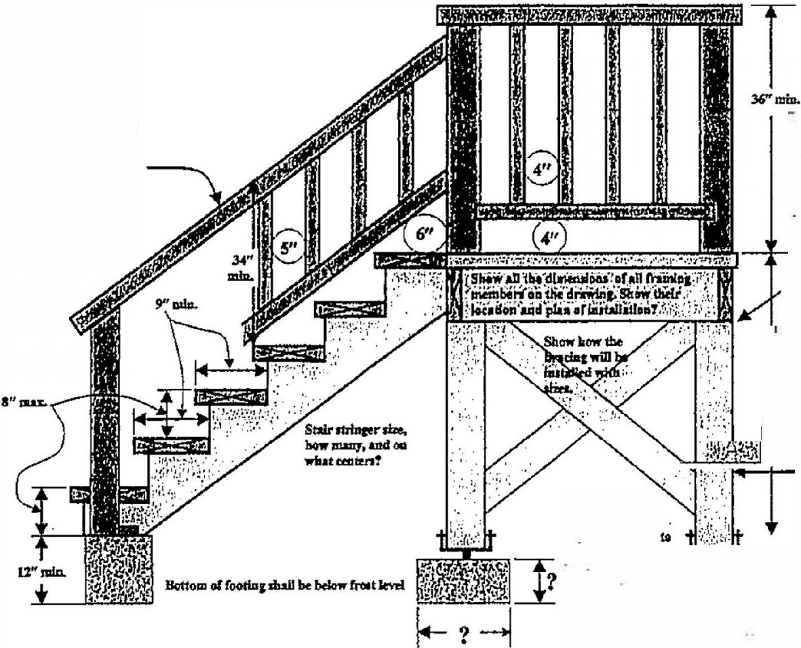
Guardrails do NOT qualify as handrails.
handrail dimensions and
See handrail handout for

requirements.

Gounl ndl

?

Positive
""""""
rootta: JMd m-.,;;!;:;;;..,

i�1! l

All framio1 mtmben:
..,.,,nu
lmllUllum bvrinz 1111 aapport, ofl½''.

Whatsizeot port! Mmtbe voua""""d•coa""-txt

R312 .1 Guards.

Guards shall be provided in accordance with Sections R312 .1.1 through R31 2.1.4.

R3 12 .1.1 Where required .
Guards shall be provided for those portions of open-sided walking surfaces, including floors, stairs, ramps and landings that are located more than 30 inches (762 mm) measured vertically to the floor or grade below at any point within 36 inches (914 mm) horizontally to the edge of the open side. Insect screening shall not be considered as a guard.

R3 12 .1.2 Height.

Required guards at open-sided walking surfaces, including stairs, porches, balconies or landings , shall be not l ess than 36 inches (914 mm) in height as measured vertically above the adjacent walking surface or the line connecting the nosings.

Exceptions:

- Guards on the open sides of stairs shall have a height of not less than 34 inches (864 mm) measured vertically from a line connect ing the nosings.
- Where the top of the guard serves as a handrail on the open sides of stairs, the top of the guard shall be not less than 34 inches (864 mm) and no t more than 38 inches (965 mm) as measured vertically from a line connecting the nosings.

C:\handout\06 example of stair detail.doc

