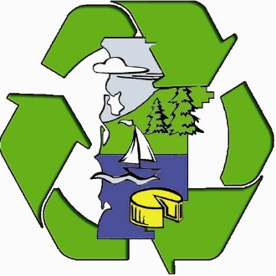 **Tillamook County**

**PUBLIC WORKS DEPARTMENT**

***Department of Solid Waste***

***Waste Prevention and Recycling*** 503 Marolf Loop Road

Tillamook, Oregon 97141 PH (503) 815-3975

FAX (503) 842-6473

Email: [recycle@co.tillamook.or.us](mailto:recycle@co.tillamook.or.us)

[www.co.tillamook.or.us/solid-waste](http://www.co.tillamook.or.us/solid-waste)

*Land of Cheese, Trees and Ocean Breeze*

Tillamook County

**Solid Waste Advisory Committee Meeting**

**Tuesday, May 13, 2025 – 3:00 pm - 5:00 pm**

**Port of Tillamook Bay, Conference Room, 4000 Blimp Blvd., Tillamook**

**and**

**Virtual meeting via TEAMS, Meeting ID: 272 891 745 375, Passcode: 6A4Bx3jE**

1. Call to Order, Welcome and Introductions 3:00 – 3:05
2. Approval of Minutes for April 18, 2025 Meeting 3:05 – 3:10

ACTION

1. Rate Review Request Approval/Discussion 3:10 – 3:30
   1. Nestucca Valley Sanitary Service
   2. R-Sanitary Service
   3. Recology Western Oregon ACTION
2. Closed Landfill Financial Assurance Contract 3:30 – 3:40
3. ODF Yard Debris Update 3:40 – 3:50
4. Recycling Modernization Act Update 3:50 – 4:00
5. Franchised Hauler Updates 4:00 – 4:15
6. Staff Report 4:15 – 4:30
7. Transfer Station Report 4:30 – 4:45
8. Public Comment 4:45 – 5:00
9. Adjourn